УДК: 81’25:81’373.423
ORCID ID 0000-0003-2460-3159
T.E. Pysmennyi
Lecturer, English Philology and Translation Department,
Alfred Nobel University (Dnipro)
A.A. Pliushchai
Senior Lecturer, English Philology and Translation Department,
Alfred Nobel University (Dnipro)
M.Y. Onishchenko
Senior Lecturer, English Philology and Translation Department,
Alfred Nobel University (Dnipro)

INTERLINGUAL HOMONYMS IN SPANISH AND ITALIAN: FALSE FRIENDS – REAL ENEMIES OF TRANSLATORS
In modern philological science, similar in sound but different in meaning words are called interlingual homonyms or, as they are often called in the circles of philologists and translators, “false friends”. Such “false friends” are “real enemies” for translators. However, there is no difference whether translation is carried out between related language groups or into other foreign languages. In this work, we will study and disclose the problems of translation and interpretation of interlingual homonyms in Spanish and Italian, being part of the group of Romance languages. The problem posed is one of the most complicated touching important aspects of the activities of modern translators. And the goal of this work is to analyze the problem of translating interlingual homonyms with the subsequent proposal to simplify understanding and study the phenomenon of homonymy. It is assumed that the list of Spanish-Italian homonyms presented in the research can be of substantial help in the practice of teaching these languages ​​for both foreign students from European countries and students who are fluent in Italian or Spanish. In the future, our methodological developments can form the basis of a special textbook on Spanish-Italian vocabulary, oriented primarily for European students and taking into account the problem of interlingual interference. In addition to the list of interlingual homonyms, the authors created a bilateral dialogue between native speakers of Spanish and Italian, where a simple, at first glance, conversation from life that leads to unpredictable unfolding and to no less unexpected ending, perfectly demonstrates what ignorance can lead to misunderstandings without clear interpretation of certain words. The authors propose to use a visual demonstration of interlingual homonyms in such situational dialogues, which will help students and translators to clearly understand the differences between certain words, and, accordingly, facilitate the perception of the material under consideration.

Key words: interlingual homonyms, Spanish, Italian, translation problems, bilateral dialogue, homonymy.

In the realities of the modern world, translators of foreign languages ​​often encounter specific difficulties in interpreting certain expressions, phraseological units, phrases, sentences, and sometimes even simple words. It is undeniable that the languages ​​of one group, for example, Romance or Germanic, have a number of similar in sound and spelling, but different in interpretation and translation of words. In modern philological science, such similar words are called interlingual homonyms or, as they are often called in the circles of philologists and translators, “false friends”. Such “false friends” are “real enemies” for translators. However, there is no difference whether translation is carried out between the related language groups or into other foreign languages.
The aim of this work is to analyze the phenomenon of homonymy in Spanish and Italian, followed by the development of a method of situational dialogue, as an option to simplify the study of interlingual homonyms for university students.
The objectives of this work are to analyze the phenomenon of homonymy in Spanish and Italian; to offer bilateral situational dialogues as a method and way to simplify the study and understanding of the phenomenon under study; to analyze interlingual homonyms in Spanish and Italian.
The method of bilateral situational dialogues presented in this work, according to the author, is able to interest modern students in the study of the phenomenon of homonymy, as well as to simplify significantly the task of understanding and interpreting them in the context of interlingual communication.
In this work we will study and disclose the problems of translation and interpretation of interlingual homonyms in Spanish and Italian being part of the group of Romance languages. The problem posed is one of the most difficult to resolve, reflecting the important aspects of the modern translator’s activity. And the goal of this work is to analyze the problem of translating interlingual homonyms with the subsequent proposal to simplify understanding and studying the phenomenon of homonymy as such.
The relevance of this theme is indicated by its popularity in the scientific community. The theme of interlingual homonyms was investigated by Armstrong B.C., Zugarramurdi C., Cabana A., Lisboa J.V., Plaut D.C. [1], Carrol G., Littlemore J., Dowens M.G. [2], Al-Wahy A.S. [3], Brumme J. [4], Dominguez P.J.C., Nerlich B. [5], Sabate-Carrove M., Chesnesvar C.I. [6], Breitkreuz H. [7], Topalova A. [8].
It is assumed that the list of Spanish-Italian homonyms presented in the research can be of substantial help in the practice of teaching these languages ​​for both foreign students from the European countries and the students who are fluent in Italian or Spanish. In the future, our methodological developments can form the basis of a special textbook on Spanish-Italian vocabulary, intended primarily for European students, sorting out the problem of interlingual interference.
In addition to the list of interlingual homonyms, the authors created a bilateral dialogue between the native speakers of Spanish and Italian, where a simple, at first glance, conversation from life has unpredictable unfolding and no less unexpected ending which perfectly demonstrates that a lack of knowledge in specificity of interpretation of certain words can lead to the most diverse situations. The authors suggest to use a visual demonstration of interlingual homonyms in such situational dialogues, which will help students and translators to clearly understand the differences between certain words, and, accordingly, to master the material easier.
False translator’s friends are lexical units that are similar in spelling or sounding in the original language and in the target language, but differ in their semantic content and direct the translator along the wrong path. False translator’s friends or interlingual homonyms (interlingual paronyms) are pair of words in two languages, similar in spelling and/or pronunciation, often having a common origin, but differing in meaning.
According to K. G. Gottlieb, “false friends” are words of two (possibly several) languages ​​that, due to the similarity of their form and content, can cause false associations and lead to an erroneous perception of information in a foreign language, and when translated, to distortions of content, errors in lexical compatibility, inaccuracies in the transmission of stylistic coloring, as well as in usage [9].
At the end of the 19th century, “false friends of translator” first attracted the attention of linguists, but then they did not receive a terminological designation, since they were not deeply studied. A systematic and extensive study of such cross-language correspondences in 1928 was first conducted on the material of the French-English and English-French parallels by the French lexicographers M. Kesler and J. Derokigny. They introduced the terms “faux amis du traducteur” (“false friends of translator”), which became common. M. Kessler and J. Derokigny in their work Les faux amis ou les trahisons du vocabulaire anglais, under the literal translation of “false friends of the translator,” meant translation only by the sound similarity of words of two languages ​​[10, p. 112].
In our country, similar dictionaries of “false friends of translator” appeared only in the late 60s and early 70th of the XX century [3, p. 108]. Since then, many other names have appeared to denote this category of words in different languages.
In philological science, this interlingual correspondence received the following terminological notation: false analogs; false analogues; dialects; interlingual homonyms; interlingual analogisms; false equivalents; false lexical parallels; pseudo-international words/pseudo-internationalisms; quasi-international words/quasi-equivalents; imaginary friends of translators [11].
Scholars introduced various definitions and classifications of these units based on the similarity of their forms and meanings. Thus, V.N. Manakin defines the interlingual homonyms as “words genetically related or borrowed (internationalisms) that are close or identical in form, but not related to each other in meaning” [12, p. 162].
E.A. Suprun also subdivides the interlingual homonyms into full and partial. The second type is characterized by the presence of a common basic meaning with a difference in its shades (emotionally expressive or functional stylistic) [13, p. 36-38]. Thus, the connotative connections of interlingual homonyms are different, which complicates their use in the same situations.
V.V. Akulenko distinguishes three categories of units: interlingual synonyms, interlingual paronyms and interlingual homonyms. Interlingual synonyms are the words of two languages ​​that fully or partially coincide in meaning and usage. Interlingual paronyms include the units that have different meanings and are not quite similar in form, but, nevertheless, cause false associations for people. Interlingual homonyms are the words of two languages, “similar to the degree of identification by sound and / or graphic form” and having different meanings [14, p. 372]. According to the scientist, errors while translating or learning of foreign languages ​​can be associated with each category [15].
It is well-known that both Spanish and Italian languages ​​originate from the language of all languages ​​– Latin. With the separation of languages, the science of translation studies began to emerge, which, as it developed, covered an increasing number of problems and controversial provisions. Trying to answer the question “how to translate?” the researchers focus on various objects of translation, which are often the sources of conflicting opinions and different views and approaches to their interpretation.
In recent years, researchers have an increased interest in the category of words called “translator’s false friends” in the translation literature, as well as interlingual relative synonyms of a similar kind, interlingual homonyms and paronyms. When translating this category of words, false identifications can occur, since interlingual analogies have some graphic (or phonetic), grammatical, and often semantic similarity. The analysis of examples of “false words of translator” shows that the greatest number of errors occurs translating international vocabulary. International parallels are characterized by a common semantic structure and are therefore easily identified in translation. However, as a result of such identifications, false equivalents often arise, since along with generality in their semantic structures there are also significant differences, which the translator can often forget about.
Based on the foregoing, the relevance of this topic lies in the fact that it is quite widespread, and the number of errors that are made not only by ordinary people, but also by the translators themselves is quite high.
The role of interlingual synonyms is played by the words of both languages ​​that fully or partially coincide in meaning and usage. They are equivalent in translation. Interlingual homonyms can be called the words of both languages, similar in degree of identification of the sound (or graphic) form, but having different meanings. Finally, the words of comparable languages, ​​which are not quite similar in form, but which can cause false associations and identify with each other, despite the fact that their meanings diverge, should be attributed to interlingual paronyms.
All these semantically heterogeneous cases are united by the practical circumstance that words, associated and identifiable (due to similarities in terms of expression) in two languages, in terms of content or in use, do not fully correspond or even completely do not correspond to each other.
In principle, one should distinguish between “false friends of translator” in oral and written forms of speech. This requirement is mandatory in the case of a comparison of languages ​​with completely different scripts or, conversely, in the case of languages ​​with a common script, but phonemic dissimilar vocabulary. [16]
Historically, “false friends of translator” are the result of the interplay of languages, in a limited number of cases they can arise as a result of random coincidences, and in related, especially closely related, languages ​​are based on the related words that come from the common prototypes in the basic language.
Translation is the interpretation of the meaning of the source text in one language and the creation of a new, equivalent text in another language so that the translated text carries the semantic load of the source text. There are two types of translation: written translation, which consists in the written transfer of meaning from one language to another and oral translation, which consists in the transfer of meaning in the oral from one language to another. [17]
Some of pairs of interlingual homonyms of the Spanish and Italian languages ​​with their translation were gathered and reflected in a situational dialogue between two speakers of Romance languages: Spanish and Italian. Within the framework of this conversation, the relevance of the problem of translation and understanding of interlingual homonyms in practice, that is, in a real life situation, will be shown.
In order to display the meanings and characteristics of mutual understanding, all replicas of this communication were translated into Russian, adapting Italian and Spanish to a Russian-speaking native speaker.
A Spanish speaker Carlos, who came to Rome for a summer vacation, will be represented in a bilateral dialogue, and Monica, representing the Italian language, will speak with him.
Table 1
Bilateral Spanish-Italian dialogue with translation into Russian
Carlos: ¡Joder! ¡Qué difícil es entender a estos italianos! Y dicen que estas lenguas son similares. No entiendo nada. Pensaba que vendría a Italia, me divertiría mucho, hablaría con italianas chulas y ahora me siento como un idiota ¡Ay, qué mierda! | Карлос: Ужас! Как же сложно понимать этих итальянцев! А еще говорят, что эти языки похожи. Ничего не соображаю. Думал, приеду в Италию, круто проведу время, пообщаюсь с классными итальянками, а теперь чувствую себя каким-то идиотом! Ай, полный отстой!
Monica: Ciao, ragazzo, posso aiutarti? Vedo che hai alcuni problemi? | Моника: Молодой человек, могу ли я тебе чем-то помочь? Я вижу, что у тебя какие-то проблемы?
Carlos: ¿Problemas? Sí, sí. Tienes razón que hay un montón de problemas. ¡He perdido el camino completamente! | Карлос: Проблемы? Да-да. Вот именно, что куча проблем. Я сбился с пути и совсем потерялся!
Monica: Stai cercando un camino? Ma perché hai bisogno di un camino? Ora siamo in estate e c’è il caldo infernale per la strada! | Моника: Ты ищешь камин? Но зачем тебе камин? Сейчас же лето и на улице адская жара!
Carlos: ¡Qué buena idea! Tengo hambre y me apetece comer caldo con gambas. ¿Vamos a comer? | Карлос: Кстати, это мысль! Я проголодался и совсем не против съесть бульон с креветками. Пойдем, поедим?
Monica: Ah, quindi le tue gambe sono congelate e per questo hai bisogno di un camino. Ma in questo momento non riesci a trovare un camino funzionante a Roma. Posso offrire qualcosa da bere. Come ti pare l'idea? | Моника: А, так у тебя замерзли ноги и вот для чего тебе камин. Но в такое время ты вряд ли найдешь работающий камин в Риме. Могу предложить выпить чего-то горячительного. Как тебе идея?
Carlos: ¿Beber algo? De acuerdo. Un vaso de whisky sería genial. | Карлос: Выпить? Я только «за». Стаканчик виски был бы кстати.
Monica: Beh, non so di un intero vaso di whisky, ma c'è un negozio vicino e ci possiamo comprare qualcosa lì. | Моника: Ну, я не знаю на счет целой вазы виски, но тут недалеко есть один магазин и там можно что-нибудь купить.
Carlos: ¡Guay! Tienes tu propio negocio de alcohol. ¡Ay, qué bien que te he conocido! ¡Vamos, vamos! | Карлос: Круто! У тебя свой алкогольный бизнес. Ай, как хорошо, что я тебя встретил! Пойдем.
Monica: Ma no, che guai? Il fatto che ci sia un negozio in città è normale, no? A proposito, c'è un ristorante accanto, la cui specialità è melanzane arroste con burro. | Моника: Нет, какая беда? То, что в городе есть магазин – это нормально, разве нет? Кстати, там по соседству есть ресторан, фирменное блюдо которого запеченные на гриле баклажаны с маслом.
Carlos: No creo que el arroz con manzanas y además con burro sea buenos entremeses para el whisky. ¿Tal vez sea mejor ir a la tasca, donde podemos comprar los bocadillos con mantequilla y caballa? | Карлос: Не думаю, что рис с яблоками и тем более ослом – это хорошая закуска к виски. Может, лучше пойдем в таверну, где можно взять бутерброды со сливочным маслом и скумбрией?
Monica: Da quale tasca hai intenzione di prendere una cavalla? E come ne farai un panino? | Моника: Из какой это сумки ты собрался достать кобылу? И как из нее ты собираешься сделать бутерброд?
Carlos: ¡Sí, sí, claro! ¡Será chulo! Y por cierto, ¿tienes una cámara? Capturemos nuestro nudo de amistad en la foto. | Карлос: Да-да, правильно! Будет круто! И кстати, у тебя есть фотоаппарат? Давай запечатлеем наши дружеские узы на фото.
Monica: Cosa vuol dire, amici nudi nella camera? Che mi fai imbarazzo! | Моника: В смысле, голые друзья в комнате? Ты что? Ты меня смущаешь!
Carlos: ¿Cuáles son los embarazos para tomar una foto? Vamos a acostarnos en el césped. Y tu hermoso pelo brillará al sol. ¡Resultará una foto maravillosa! | Карлос: Какие могут быть препятствия, чтобы сделать фото? Давай ляжем на газон. Как раз твои красивые волосы будут блестеть на солнце. Получится классная фотка!
Monica (pensando): È un po´ strano! Suggerisce di accostarсi nudi sul prato e allo stesso tempo essere fotografati. E perché lui ha detto della bellezza dei miei peli? Mi sembra che bisogna domandare qualcosa a lui. (a Carlos): voglio domandare una cosa! Sei un maniaco?! | Моника (думает про себя): Какой-то он странный! Предлагает ласкаться раздетыми на газоне и при этом фотографироваться. И при чем здесь красота моих волос на теле? Мне кажется, что нужно кое-что у него узнать.(к Карлосу): Хочу у тебя кое-что спросить! Ты маньяк?!
Carlos: ¡Basta, basta! ¡No soy maníaco! No hay necesidad de demandar contra mí! ¡Malditos, locos italianos! | Карлос: Стоп-стоп! Я не маньяк! Не нужно возбуждать против меня дело! Кошмар, чокнутые итальянцы!

To visually illustrate the difficulty of recognizing and revealing in practice the interlingual homonyms of the Spanish and Italian languages, the author proposes a combined table of 10 pairs of “false friends of the translator” with a mutual interpretation and etymological analysis, presented below.
Table 2
Analysis of interlingual homonyms in Spanish and Italian
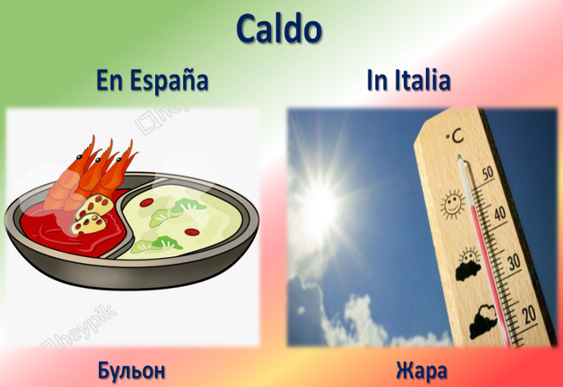 | The etymology of the word “caldo” originates from the Latin “calidus”, which means “hot”. In Spanish, this word has acquired the meaning of “hot broth”; while in Italian it has retained its original interpretation as “heat”. Such a mismatch causes problems in understanding translation in the process of intercultural communication.
The etymology of the word “guay/guai” originates from the German exclamation of the wáwa, which is used to express painful sensations. In Spanish, this word has acquired an antonym meaning and is translated as “cool”, while in Italian it has retained a close interpretation and translated as “trouble”. Such a mismatch causes problems in understanding translation in the process of intercultural communication. | 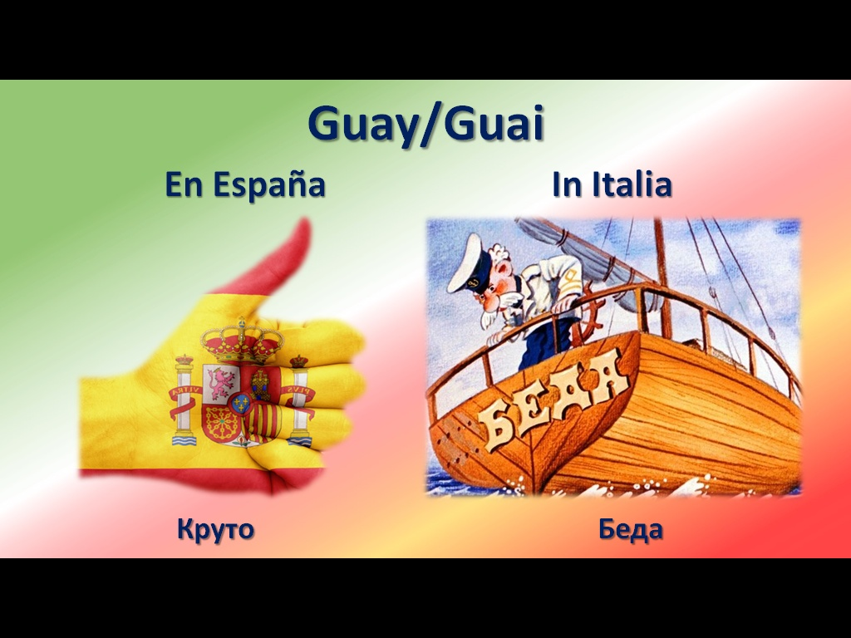
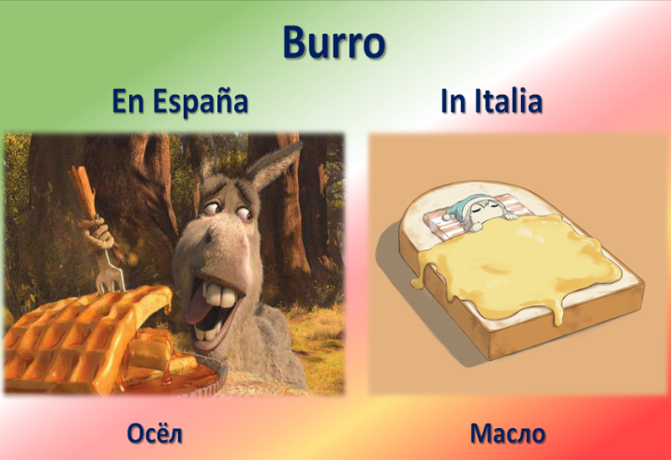 | The etymology of the word “burro” originates from the Latin “butyrum”, which translates as “butter”. From it came the Italian word “burro”, which also means “butter”. In Spanish, the word burro comes from another Latin word “borrico”, which means “donkey”. Such a mismatch causes problems in understanding translation in the process of intercultural communication.
The etymology of the word “nudo” originates from the Latin “nudus”, which translates as “naked”. From him came the Italian word “nudo”, which is also interpreted as “naked”. This word has a similar meaning in Spanish, but there is also a different meaning presented in the dialogue – “knot” or “tie”, which originates from the Latin “nodus”. Such a mismatch causes problems in understanding translation in the process of intercultural communication. | 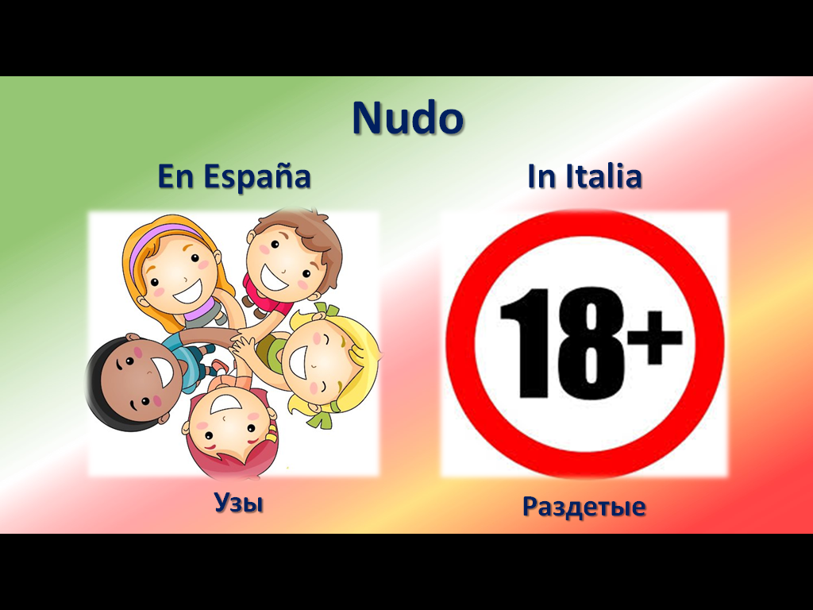
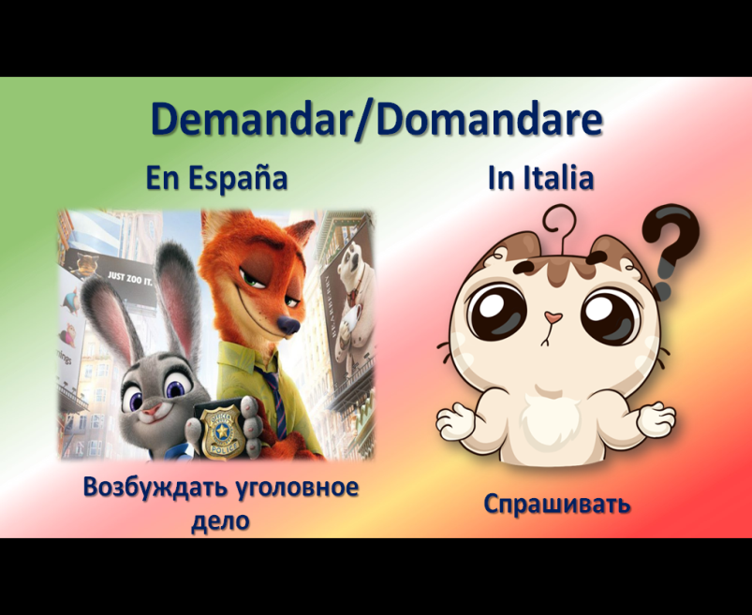 | The etymology of the word “domandare” originates from the Latin “demandare”, which translates as “demand”. From which there is the Italian word “domandare”, which is interpreted as the verb “ask”. In Spanish, the word “demandar” also comes from the Latin “demandare”, but has received a different connotation and means “sue” or “institute criminal proceedings”. Such a mismatch causes problems in understanding translation in the process of intercultural communication.

Analyzing the bilateral dialogue presented in this work using the interlingual homonyms of the Spanish and Italian languages, we can conclude that only good knowledge of the translation of “false friends” can help to modern translators to recognize and correctly interpret them in practice. The method of situational dialogues proposed by the authors can facilitate understanding of homonymy in Spanish and Italian, making the study of this phenomenon simpler and more accessible for students.
In the example shown, it is clearly visible what the incorrect interpretation of interlingual homonyms can lead to misunderstandings. And, as it is seen, a usual situation in everyday life can lead to an unpredictable conclusion. That is why this topic is very relevant in the modern world and is interesting to study both for native speakers and translators.
Conclusion. Translators should be able to deliver the intended meaning written in the source language to the target language without changing the purpose of the source text at all [18, p. 11]. The “false friends” of translators project an incorrect understanding and, subsequently, an incorrect interpretation of a word or a conversation. At a subconscious level, the translator uses the interpretation that is similar in sound to the translated word, which often leads to a distortion of the true meaning of what was said. And if we are talking about native speakers of related languages, as seen in the considered pair of Spanish and Italian, this situation is quite common.
In order to avoid such incorrect situations with distorted perception and transmission of the meaning of what was said, one should thoroughly study the phenomenon of interlingual homonyms and clearly demonstrate to future translators the contextual cases of interpreting “false friends”, as has been shown in the bilateral dialogue between native speakers of Spanish and Italian.
Bibliography
1. Armstrong B.C., Zugarramurdi C., Cabana A., Lisboa J.V., Plaut D.C. Relative meaning frequencies for 578 homonyms in two Spanish dialects: A cross-linguistic extension of the English eDom norms / B.C. Armstrong, C. Zugarramurdi, A. Cabana, J.V. Lisboa, D.C. Plaut – Behavior Research Methods – Harlow: Pearson Publ., Vol. 3, issue 48, 2016 – 962 p.
2. Carrol G., Littlemore J., Dowens M.G. Of false friends and familiar foes: Comparing native and non-native understanding of figurative phrases / G. Carrol, J. Littlemore, M.G. Dowens – Lingua – Amsterdam: Elsevier Publ., issue 204, 2018 – 589 p.
3. Al-Wahy A.S. Semantics and pragmatics of false friends / A.S. Al-Wahy – Canadian journal of linguistics-revue canadienne de linguistique – Cambridge: Cambridge University Press Publ., Vol. 2, issue 55, 2010 – 476 p.
4. Brumme J. "False friends": Portuguese-German, German-Portuguese / J. Brumme – Zeitschrift fur romanische philology – Tübingen: Max Niemeyer Verlag Publ., Vol. 4, issue 119, 2003 – 856 p.
5. Dominguez P.J.C., Nerlich B. False friends: their origin and semantics in some selected languages / P.J.C. Dominguez, B. Nerlich – Journal of pragmatics – Amsterdam: Elsevier Publ., Vol. 12, issue 34, 2002 – 2345 p.
6. Sabate-Carrove M., Chesnesvar C.I. False friends in English-Spanish translations in computer science literature / M. Sabate-Carrove, C.I. Chesnesvar – Perspectives-studies in translatology – London: Taylor & Francis Publ., Vol. 1, issue 6, 1998 – 348 p.
7. Breitkreuz H. Italian false friends – Ferguson, R / H. Breitkreuz – IRAL-international review of applied linguistics in language teaching – Berlin: Walter de Gruyter Publ., Vol. 3, issue 35, 1997 – 542 p.
8. Topalova A. ''False-friends'' in translation work: An empirical study / A. Topalova – Perspectives-studies in translatology – London: Taylor & Francis Publ., Vol. 2, issue 4, 1996 – 394 p.
9. Акуленко В.В. Англо-русский и русско-английский словарь «ложных друзей переводчика» / В.В. Акуленко – М.: Советская энциклопедия, 1969. – 384 с.
10. Koessler M., Derocquigny J. Les faux amis ou les trahisons du vocabulaire anglais. Conseils aux traducteurs / M.Koessler, J.Derocquigny – Paris, Vuibert Publ., 1928. – 424 p.
11. Басманова А.Г. Именные части речи во французском языке / А.Г. Басманова – М.: Просвещение, 1991. – 160 с.
12. Манакин В.Н. Сопоставительная лексикология / В.Н. Манакин – Киев: Знания, 2004. – 326 с.
13. Супрун А.Е. Лексическая типология славянских языков / А.Е. Супрун – Минск: Изд-во БГУ, 1983. – 47 с.
14. Апетян М.К. Ложные друзья переводчика в английском языке // Молодой ученый / М.К. Апетян – 2014. – № 14. – С. 91-93. (Просмотрено: 17.10.2019).
15. Краснокутская Н.В. Проблема межъязыковой омонимии в преподавании русского языка как иностранного европейским учащимся. Интернет-журнал «Мир науки» / World of Science. Pedagogy and psychology, 2018, Том 6, № 1. Режим доступа: https://mir-nauki.com/issue-1-2018.html (Просмотрено: 07.10.2019)
16. Борисова Л.И. Ложные друзья переводчика / Л.И. Борисова – М.: НВИ-Тезаурус, 2010. – 211 с.
17. Казакова Т.А. Теория перевода / Т.А. Казакова – М.: Издательство «Восток-Запад», 2009 – 55 с.
18. Novriyanto N., Hasan R. Translation problems analysis of students’ academic essay / N. Novriyanto, R. Hasan – International Journal of Linguistics, Literature and Translation (IJLLT) – Jakarta.: Crossref Publ., Vol. 2, issue 5, 2019 – 443 p.
References
1. Armstrong B.C., Zugarramurdi C., Cabana A., Lisboa J.V., Plaut D.C. Relative meaning frequencies for 578 homonyms in two Spanish dialects: A cross-linguistic extension of the English eDom norms. Behavior Research Methods. Harlow, Pearson Publ., Vol. 3, issue 48, 2016 – 962 p.
2. Carrol G., Littlemore J., Dowens M.G. Of false friends and familiar foes: Comparing native and non-native understanding of figurative phrases. Lingua. Amsterdam, Elsevier Publ., issue 204, 2018 – 589 p.
3. Al-Wahy A.S. Semantics and pragmatics of false friends. Canadian journal of linguistics-revue canadienne de linguistique. Cambridge, Cambridge University Press Publ., Vol. 2, issue 55, 2010 – 476 p.
4. Brumme J. "False friends": Portuguese-German, German-Portuguese. Zeitschrift fur romanische philology. Tübingen, Max Niemeyer Verlag Publ., Vol. 4, issue 119, 2003 – 856 p.
5. Dominguez P.J.C., Nerlich B. False friends: their origin and semantics in some selected languages. Journal of pragmatics. Amsterdam, Elsevier Publ., Vol. 12, issue 34, 2002 – 2345 p.
6. Sabate-Carrove M., Chesnesvar C.I. False friends in English-Spanish translations in computer science literature. Perspectives-studies in translatology. London, Taylor & Francis Publ., Vol. 1, issue 6, 1998 – 348 p.
7. Breitkreuz H. Italian false friends – Ferguson, R. IRAL-international review of applied linguistics in language teaching. Berlin, Walter de Gruyter Publ., Vol. 3, issue 35, 1997 – 542 p.
8. Topalova A. ''False-friends'' in translation work: An empirical study. Perspectives-studies in translatology. London, Taylor & Francis Publ., Vol. 2, issue 4, 1996 – 394 p.

9. Akulenko V.V. Anglo-russkiy i russko-angliyskiy slovar’ “lozhnikh druzei perevodchika” [English-Russian and Russian-English Dictionary of “False Translator Friends”]. Moscow, Sovetskaya entsiklopedia [Soviet encyclopedia], 1969. – 384 p.
10. Koessler M., Derocquigny J. Les faux amisou les trahisons du vocabulaireanglais. Conseils aux traducteurs. Paris, Vuibert Publ., 1928. – 424 p.
11. Basmanova A.G. Imennyie chasti rechi vo franzuzskom yazike [Named parts of speech in French]. Moscow, Prosveschenie Publ. [Enlightenment], 1991. – 160 p.
12. Manakin V.N. Sopostavitelnaya lexicologiya [Comparative lexicology]. Kiev, Znaniya Publ., 2004. – 326 p.
13. Suprun A.E. Lexicheskaya tipologiya slavyanskikh yazikov [Lexical typology of Slavic languages]. Minsk, BGU Publ., 1983. – 47 p.
14. Apetyan M.K. Lozhnie druzya perevodchika v angliyskom yazike // Molodoy ucheniy [False translator friends in English // Young scientist]. 2014. – № 14. – С. 91-93. (Accesed 17 October 2019).
15. Krasnokrutskaya N.V. Problema mezhyazikovoi omonimii v prepodavanii russcogo yazika kak inostrannogo evropeiskim uchaschimsya. Internet zhurnal “Mir nauki”. [The problem of interlingual homonymy in teaching of Russian as a foreign language to European students. Internet magazine “World of Science” / World of Science. Pedagogy and psychology], 2018, Vol. 6, no. 1. Available at: https://mir-nauki.com/issue-1-2018.html (Accessed 07 October 2019)
16. Borisova L.I. Lozhnie druzya perevodchika [False translator friends]. Moscow, NVI-Tezaurus Publ., 2010. – 211 p.
17. Kazakova T.A. Teoria perevoda. [Translation theory]. Мoscow, “Vostok-Zapad” Publ., 2009 – 55 p.
18. Novriyanto N., Hasan R. Translation problems analysis of students’ academic essay. International Journal of Linguistics, Literature and Translation (IJLLT). Jakarta, Crossref Publ., Vol. 2, issue 5, 2019 – 443 p.

В современной филологической науке схожие по звучанию, но различные по значению слова получили название межъязыковых омонимов или, как их нередко называют в кругах филологов и переводчиков, «ложные друзья». Такие «ложные друзья» являются «настоящими врагами» для переводчиков, при этом, нет различия, осуществляется ли перевод между родственными языковыми группами или на другие языки. В данной работе исследованы и раскрыты проблемы перевода и интерпретации межъязыковых омонимов в испанском и итальянском языках, которые входят в группу романских. Поставленная проблема является одним из наиболее сложных в разрешении, а потому важных аспектов деятельности современных переводчиков. И целью данной работы является анализ проблемы перевода межъязыковых омонимов с последующим предложением упрощения понимания и изучения явления омонимии. Предполагается, что приведенный в исследовательской работе перечень испано-итальянских омонимов может оказать существенную помощь в практике преподавания этих языков как для иностранных учащихся из европейских стран, так и студентам, которые достаточно хорошо владеют итальянским или испанским языками. В дальнейшем наши методические разработки могут лечь в основу учебного пособия по испано-итальянской лексике, предназначенного, в первую очередь, для европейских учащихся и учитывающего проблему межъязыковой интерференции. Помимо списка межъязыковых омонимов, авторами был разработан билатеральный диалог между носителями испанского и итальянского языков, где наглядно продемонстрирован простой, на первый взгляд, разговор из жизни, который приводит к непредсказуемому развитию и не менее неожиданному финалу, показывающему, к чему может привести незнание специфики трактовки тех или иных слов. Авторы предлагают использовать наглядную демонстрацию межъязыковых омонимов в подобных ситуативных диалогах, которые помогут учащимся и переводчикам понимать различия между теми или иными словами, и, соответственно, проще усваивать материал.

Ключевые слова: межъязыковые омонимы, испанский язык, итальянский язык, проблемы перевода, билатеральный диалог, омонимия.

У сучасній філологічній науці схожі за звучанням, але різні за значенням слова отримали назву міжмовних омонімів або, як їх нерідко називають в колах філологів і перекладачів, «хибні друзі». Такі «хибні друзі» є «справжніми ворогами» для перекладачів, хоча, нема різниці, чи здійснюється переклад на споріднені чи інші мови. У даній роботі досліджені і розкриті проблеми перекладу та інтерпретації міжмовних омонімів в іспанській та італійській мовах, які входять в групу романських. Проблема, що висвітлюється, є однією з найбільш складних у вирішенні, а також важливою серед аспектів діяльності сучасних перекладачів. Метою даної роботи є аналіз проблеми перекладу міжмовних омонімів з подальшою пропозицією спрощення розуміння і вивчення явища омонімії. Передбачається, що наведений в дослідницькій роботі перелік іспано-італійських омонімів може надати істотну допомогу в практиці викладання цих мов як для іноземних учнів з європейських країн, так і студентам, які досить добре володіють італійською або іспанською. Методичні розробки можуть лягти в основу навчального посібника з іспано-італійської лексики, призначеного, в першу чергу, для європейських здобувачів та з урахуванням проблем міжмовної інтерференції. Крім списку міжмовних омонімів, авторами було розроблено білатеральний діалог між носіями іспанської та італійської, де наочно продемонстровано просту, на перший погляд, розмову з життя, яка призводить до непередбачуваного розвитку і не менш несподіваного фіналу, що чудово показує, до чого може привести незнання специфіки трактування тих чи інших слів. Автори пропонують використовувати міжмовні омоніми в подібних ситуативних діалогах, що допоможе здобувачам і перекладачам чітко розуміти відмінності між тими чи іншими словами, і, відповідно, простіше засвоювати матеріал.

Ключові слова: міжмовні омоніми, іспанська мова, італійська мова, проблеми перекладу, білатеральний діалог, омонімія.

