ALFRED NOBEL UNIVERSITY
DEPARTMENT OF GLOBAL ECONOMICS

QUALIFICATION WORK OF BACHELOR

“Development of international investment
project “Park in UAE””

Fourth year student,
group IER16-English
in specialty 292
“International economic relations”
Mashkova D.A..

Supervisor: Lymonova E.N.
Candidate of Economic Sciences.

Dnipro, 2020

ALFRED NOBEL UNIVERSITY

Department of the Global Economics

First (bachelor) level
Specialty 292 International economic relations
Approved:
Head of Department _________________
_____________________________________
____________________________________
(signature, last name, initials, scientific degree, academic status)

“____” __________________20__ р.

TASKS
for qualification work

Mashkova Daria
Student’s last name, name
1. “Development of international investment
project “Park in UAE”
2. Supervisor Limonova E.N., Candidate of economic sciences
(last name, initials, scientific degree, academic status)

Approved by order of "___" _____________ 20___, No. _______________
3. Deadline for submission of work completed by the __________________________
4. Target installation and baseline data __________________________________________________________
5. Content of the work (list of questions to be developed):
SECTION 1. Analysis of investment climate in UAE
1.1. FDI investments.
1.2. Investment climate in UAE
1.3 Export - import activity in UAE
1.4 Economical statistics
SECTION 2. Development of an international investment projet to establish a park in UAE
2.1. Legislative system and taxation
2.2. Environmental benefits of the project
2.3. Opening a business
SECTION 3. Financial plan and calculations
3.1. Determining location of a project and its benefits
3.2. Estimated calculations of costs,wages and income of the project
3.3. Projects efficiency
6. Date of issue of the assignment ______________________
7. Calendarofworkexecution
no | Name of the stages of qualification work | The deadline for the work stages
no | Name of the stages of qualification work | accordingtotheplan | infact
1 | Attachment of the supervisor of qualification work
2 | Selection and discussion of the topic of qualification work
3 | Final approval of the topic of qualification work
4 | Obtaining a job for a qualification work from a supervisor
5 | Compilation of bibliography and study of literary sources
6 | Performingthefirstsection
7 | Collection of materials at the enterprise
8 | Performingthesecondsection
9 | Performingthethirdsection
10 | Drawingconclusionsandrecommendations
11 | Design of work, receiving feedback
12 | Preliminary protection of qualification work
13 | Protectionofqualificationwork

Student _________ Mashkova D.A.
signaturelastname, initials

Supervisor _________ Limonova E.N.
signaturelastname, initials
Summary
“ Development of international investment
project “Park in UAE””

The paper deals with study of general economic growth features of the UAE. Consideration is given to the major UAE economy and tourism sector industries. It outlines the main trends in UAE's export-import activity and its place in international economic relations. It provides analysis of UAE 's international trade and foreign direct investment. Assessment of the economic climate and UAE 's investment role is given. The degree of its attractiveness to Ukrainian investors, the key advantages and future risks to a foreign investor.
The core premise of an international investment project to commence at the UAE is provided with the principles , methods and directions to render investments. The entertainment industry is being considered to represent these tasks, as are the required parts of it too. The substantiation of the investment project for park creation in the UAE is presented, the assessment of the need for investment resources and the identification of sources of their involvement. Estimation of expected income and assessment of the investment project's economic efficiency are done.

Key words: UAE economy, tourism, international trade, foreign direct investment, investment climate, investment project, economic effectiveness.

Анотація
“Розробка міжнародного інвестиційного проекту щодо створення парку в ОАЕ”

У роботі розглянуто загальні особливості економічного зростання ОАЕ. Розглядається основна галузь економіки ОАЕ - туризм. Визначено основні тенденції експортно-імпортної діяльності ОАЕ та її місце в міжнародних економічних відносинах. Надано аналіз міжнародної торгівлі ОАЕ та прямих іноземних інвестицій. Описана оцінка економічного клімату та інвестиційної ролі ОАЕ та ступінь його привабливості для українських інвесторів, ключові переваги та майбутні ризики для іноземних інвесторів.
Основна передумова міжнародного інвестиційного проекту, який розпочинається в ОАЕ, забезпечується принципами, методами та вказівками щодо здійснення іноземних інвестицій. Представлено обґрунтування інвестиційного проекту створення парків в ОАЕ, оцінка потреби в інвестиційних ресурсах та визначення джерел їх залучення. Проведено оцінку очікуваного доходу та оцінку економічної ефективності інвестиційного проекту.

Ключові слова: економіка ОАЕ, туризм, міжнародна торгівля, прямі іноземні інвестиції, інвестиційний клімат, інвестиційний проект, економічна ефективність.

DEVELOPMENT OF INTERNATIONAL INVESTMENT
PROJECT PARK IN UAE

CONTENT

Introduction 7
Section 1: Analysis of investment climate in UAE 10
1.1 FDI investments 11
1.2 Investment climate in UAE 14
1.4 Export - import activity of UAE 18
1.5 Economical statistics 23
Section 2: Development of an international investment projet to establish a park in UAE 27
2.1 Legislative system and taxation 27
2.2 Environmental benefits of the project 30
2.3 Opening a business 33
Section 3: Financial plan and calculations 37
3.1 Determining location of a project and its benefits 37
3.2 Estimated calculations of costs,wages and income of the project 38
3.3 Projects efficiency 43
Conclusion 47
References 49

INTRODUCTION
The project's goal is to establish an investment opportunity for a certain Ukrainian company engaged in the entertainment industry. The standard of all established parks is as follows: no more than 2000 sq m,attendance of more than 500 people per day and more than 70% of positive reviews. The company has gained enough to invest in a new project, and shareholders would like it to be an international project to implement a Ukrainian project in another climate zone. The name of the project shall be connected with flora,since our company is engaged in landscaping through parks,so the project's name shall be “Desert Oasis”.
This international investment project should not exceed $2.000.000 and meet the requirements of payback period to be no longer than 3 years. The definition of the foreign investment project should be detailed and considerate of the most significant economic and political developments in the country chosen, should concentrate on its tax and legal policy, should include advisory notes on the process of investment transfer between the country and Ukraine,havea appropriate estimate of the expected expenditure and does not concentrate on the maximum potential production, so that the foreign investment project offers a ready-made investment plan.
For this project the United Arab Emirates has been chosen, as this country attracts a large number of tourists, as well as at the legislative level supports any projects related to the greening of the state. The concept behind the project is to create an open space for visitors to relax and enjoy their stay,while realizing that this park is located in the middle of dessert. While the thermometer shows +50 Celsius, they can enjoy the coolness while walking along the alleys of the park.
The purposeof the thesis is to analyze the macroeconomic situation in UAE and its investment climate, to assess the prospects for the development of an investment project for opening a park in UAE
The tasks of the thesis are:
- To research the general characteristics of the development of the economy of UAE;
- To evaluate structural changes in the economy of UAE;
- To study the main trends of the UAE entertainment sector;
- To analyze the main trends in export-import activity of UAE;
- To evaluate the business environment and the investment position of UAE;
- To consider the investment climate in UAE and the degree of its attractiveness to Ukrainian investors;
- To develop the investment project for the opening of a park in UAE and the assessment of the need for investment resources;
- To assess estimated income and economic effectiveness of the investment project.
The object of study are the international relations and business climate in UAE for foreign investors.
The subject of study is the development of international project in UAE.
Method. During the study, general scientific methods of cognition, analysis and synthesis, a process approach, methods of systemic, strategic, economic and statistical analysis were used.
The practical significance of the work means that it is possible to develop directions for the development of international project, as well as implement a real investment project to open a park in UAE.
The first section of the paper deals with the analysis of general characteristics of the development of UAE economy. The main industries of UAE economy and investment climate are considered. The main trends in export-import activity of UAE and its place in international economic relations is investigated.
The second section describes development of an international investment project to establish a park in UAE .The analysis of market and economic opportunities.The business environment and incorporation procedures.The degree of its attractiveness to Ukrainian investors, comprehension of the country's legislative and tax framework.
The third section provides a rationale for the main idea of an international investment project to implement in UAE, the values, forms and ways of making investments. Step-by-step preliminary calculations are made. The calculations of future investments, profit, profitability, payback and forecasts for future project development are done.
The conclusions and proposals contain the generalized findings of the research and development of the international investment project, the main scientific and practical results, and recommendations for practical use.
The list of references includes sources of information used in the thesis. List consists of legislative acts, regulations, domestic and foreign scientific and special literature, professional publications, electronic resources.

SECTION 1
ANALYSIS OF INVESTMENT CLIMATE IN UAE
The United Arab Emirates has achieved tremendous results since its inception. Today, it is one of the fastest growing economies in the world. Several decades ago, the United Arab Emirates was considered one of the poorest and weakest developed regions among the Gulf countries, with a population of about 180,000, which was of no interest to foreign capital. The region now has a high GDP per capita and a rapidly growing economy with a growing population of about nine million today. The UAE is recognized mutually of the foremost open economies within thecentreEast and a pioneer at being the primary cosmopolitan hub for business within the geographic area. The UAE is in the list of the highest ten oil-producing countries within theworld(Facts, 2020). Located in the Arabian Gulf, the UAE demographic statistics indicate a population of about 9.89 million people with a free-market economy(Worldpopulationreview.2020). In fact, even with the current global economic meltdown, the economy of UAE has remained steady and resilient.UAE’s fast development pays off:the country becomes one the best choices for overseas expansion.The economy of the Arab Emirates remains so resilient, despite all crises, thanks to diversification. Since the beginning of its history as part of the Emirates, Dubai has followed a strategy of diversification and reducing dependence on black gold. The Emirates are a country of contrasts. On the one hand, it is a turbulent, dynamic region, but its political stability is breaking all records. Personal security in the Emirates is at the highest level, and although the state's main wealth is oil, the economy is not too dependent on it. In 2019, experts are confident that the Emirates will be able to overcome a small investment crisis with honor, and therefore there is no reason to worry about the economic situation in the country.
1.1 FDI investments
To add to the development of UAE active participation in globalization is one of the most necessary actions required for UAE to attract foreign direct investment (FDI) and thus further strengthen the economy. To do so, UAE has ventured in its well-known real estate in order to increase its wealth. The result of these ventures is that UAE is able to attract huge amounts of FDI from the outer world. At the moment, the level of FDI in UAE is high mostly because it’s coming from Europe, USA, UK and Russia(santandertrade.2020). UAE's economic prosperity is based on oil and gas exports. Until the 1950s, the UAE economy was in decline, with fishing and pearling being the main industries(Map and Facts, 2020). After the oil fields were closed, oil production began to increase. Beginning in 1962, Abu Dhabi became the first emirate to export oil(History, 2020). From a region consisting of small desert principalities, the UAE has evolved into a country with a high standard of living. Since the mid-1980s, the Government of the United Arab Emirates has been puzzled by the issue of economic diversification, as the oil reserves on which the country's economy is built are not sufficient guarantees of stable growth in the long run. Thus, the most promising way to support the State's development is to attract foreign investment. In order to encourage foreign direct investment in the region, the Government has streamlined its legislation and focused on creating a favourable investment climate. 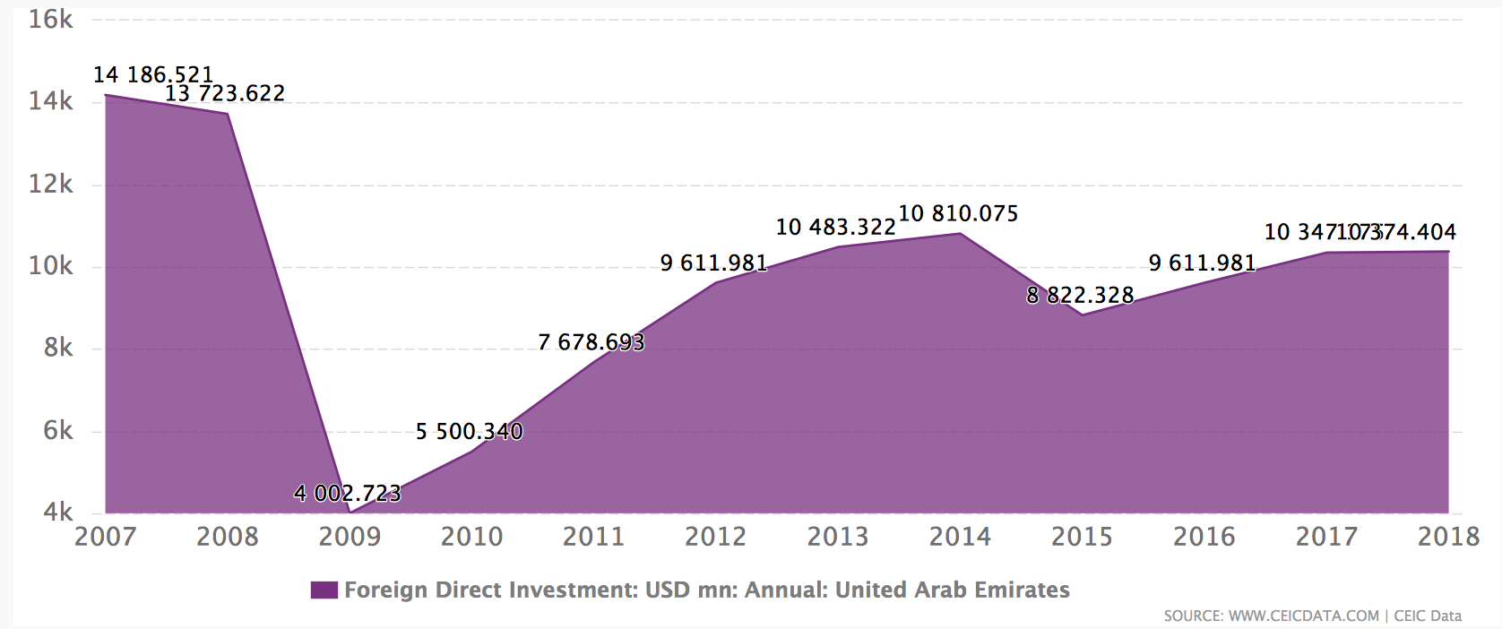
Fig.1.1 FDI Investment (USD)
The United Arab Emirates has thus demonstrated a positive trend in foreign direct investment flows to a country with a shockingly low capital outflow. The increase in investment is indicative of the region's increased attractiveness to foreign capital. Foreign investment is considered an important and necessary component for sustainable development in the United Arab Emirates. Foreign direct investment (FDI) is generally preferred to other forms of financing, as it does not contribute to debt creation and, at the same time, its return depends entirely on the implementation of a project financed by a foreign investor. In order to take full advantage of FDI and contribute to sustainable economic development, it is essential that the main elements of economic growth interact with foreign and domestic investment policies and priorities.
Foreign investment is the basis for the development of the national economy. Investing in various types of activities, the receiving parties accumulate and transform their fixed capital, pursue a policy of economic diversification, improve the quality of products, as well as implement the most important projects and programs(Hbs.edu.2020). Foreign investment plays an important role in the formation of the economy of any state. At present, the attraction of foreign investments is one of the most important factors that determines the growth of the country's economy and its competitiveness in the world. Besides, the inflow of direct foreign investments into the country promotes integration and structural change in the economies of member states. Many countries are actively looking for ways and means to attract foreign capital, as this is accompanied by a number of advantages for the host country: acceleration of economic development, creation of new jobs, exchange of experience, increasing the competitiveness of local companies, attracting advanced technology, improving export performance. The Federal Law on Foreign Direct Investment sets new requirements for foreign ownership and allows foreigners to own up to 100% of the share capital in companies registered in the UAE and operating in certain sectors (according to licensing requirements). The sectors covered by the new regime will be defined in regulations that have not yet been issued. Existing foreign ownership restrictions will continue to apply generally for sectors not yet covered by the new regime. The main objectives of the FDI Act are to promote foreign direct investment in the UAE, especially in priority sectors that will contribute to the country's sustainable economic development. The law applies to any foreign investment in the capital of legal entities.
It applies to:
-limited liability companies;
-public limited companies; and
-private joint stock companies.
If a foreign investor seeks to invest in a company in Dubai operating in a sector that is on the list of permitted activities, it is necessary to apply for a license for foreign investment in the Arab Emirates. Companies that have been able to obtain a licence for foreign direct investment in the UAE will be included in a new register maintained by the FDI Unit. It should be noted that such companies also need to obtain a commercial license in the Emirates from the Licensing Authority, as well as other necessary industry licenses.
UAE companies licensed for foreign direct investment should generally be regarded as domestic companies (as if they were 100% owned by UAE citizens) to the extent permitted by law. However, it is important to understand that any changes in equity, amendments to the memorandum or articles of association, M&A in the UAE require the consent of the relevant regulators. Although the UAE as a whole has a significant record of FDI inflows as well as outflows, the distribution of foreign investment is not equally distributed among all emirates creating a form of FDI inflow race or competition within the country. In the UAE, Dubai, as an emirate, remains the largest recipient of foreign direct investment by all measures at present.
Foreign capital entering the country comes with many advantages for the host country. At first glance, the government seems to have no serious reason to limit the flow of investment. Nevertheless, each government is concerned about developing measures to manage inflows and outflows of foreign capital, including by regulating the amount of funds received and their subsequent allocation.
1.2 Investment climate in UAE
The United Arab Emirates is known throughout the world as a popular destination with optimal conditions for attracting foreign direct investment. Due to the fact that this status is regularly confirmed not only by representatives of UAE government and business structures, but also by reputable independent foreign experts in the field of business and finance, regional and foreign investors are actively considering investing in a dynamically developing economy that has firmly established itself as a safe haven for investment.
Countries with a favorable investment climate have to meet a number of requirements for local and foreign investors to be interested in local market opportunities. In October 2015, the UAE Minister of Economic Affairs, Sultan bin Saed Al Mansouri, announced that the total volume of foreign direct investment attracted to the country over the past ten years from more than 500 foreign corporations had exceeded $100 billion. According to the Minister, today the UAE represents the most important centre of commercial activity for the entire Middle East region, as it is characterized by optimal transport accessibility and, due to its developed network of land, air and water transport, provides an unimpeded environment. To a large extent, the rapid development of the Emirates' economy is explained by the government's measures to diversify it, aimed at reducing the country's dependence on oil production and exports. It is reported that the non-oil sector's contribution to UAE GDP currently stands at 69% - thus, the country's economy is only one-third dependent on oil resources. By comparison, at the early stage of the country's economic formation, immediately after the discovery of oil deposits, the UAE economy was 90% dependent on this resource. The Government states that the strategic plans for the further development of the Arab Emirates envisage reducing the country's dependence on oil to 20% over the next decades. It is noted that in the course of economic diversification, special attention will be paid to support the development of the tourism industry, hospitality, financial services, manufacturing and real estate in the UAE.
The first step towards creating a global, liberal and competitive business environment was taken in 1995 when the UAE joined the World Trade Organization (WTO)(World Trade Organization - Global trade, 2020). The WTO agreements had a direct impact on domestic services in insurance, banking, transport, tourism, investment and construction - everything that would be needed to improve productivity and global competitiveness(MSD, 2020). In order to maintain a favourable investment climate in the United Arab Emirates, the Dubai International Financial Centre (DIFC) was established in 2004(TenTwenty | Webdesign, 2020). The financial sectors that operate in the centre include: banking services, capital markets, asset management and Islamic finance. The federal government does not levy taxes on profits or on the material benefits of individuals and entities. However, most emirates have adopted internal acts regulating taxation issues(Bakermckenzie.2020). According to these acts, profits can be taxed at a rate of up to 50% on taxable profits of companies that have ever been established(santandertrade.com.2020). In practice, the application of the acts is limited to oil exporting companies and foreign banks. Some emirates set local taxes. In the Emirate of Dubai, a 10% tax is imposed on hotel income and income from entertainment services. All emirates except Abu Dhabi are subject to a 10% tax on profits from renting commercial real estate and a 5% tax on profits from renting accommodation(santandertrade.com.2020). In the Emirate of Abu Dhabi, income from renting out real estate is tax exempt, but owners of rented real estate are subject to an annual license fee of a fixed amount(Uk.practicallaw.2020).
The United Arab Emirates is one of the most favourable regions from the Gulf countries.The UAE simplified the process of obtaining a construction permit: the number of procedures was reduced from 9.0 to 8.0.(Dealing with Construction Permits Reforms - Doing Business - World Bank Group, 2020) The United Arab Emirates responds to many factors that determine the region's attractiveness for foreign direct investment. It can equally meet the needs of investors who are looking for raw materials and direct access to resources. A well-developed private sector: A simplified process for starting a business, registering property, is another feature that determines the flow of FDI into a country. An important factor determining the nature of the financial environment in the UAE is the repatriation rule. According to this rule, the company's capital must be repatriated to its home country. This requirement applies to all entities in the free economic zones. Speaking about political stability,due to serious government control, there are no political parties or opposition movements, which explains the relatively stable situation in the UAE.
The Government of the UAE is actively engaged in increasing the region's attractiveness to foreign capital and has created about 40 free economic zones (FEZs) to strengthen the UAE's position in the world and improve the country's investment climate(Pkf.com.2020). FEZ provides various advantages for foreign investors: the possibility of doing business with 100% participation, a simplified taxation system, a wide range of activities, resident visas and residence permits for the company's founders and employees. More than half of the zones are located in Dubai (23), Abu Dhabi (5), Ras Al Khaimah (4), Fujairah (3), Sharjah (2), Ajman (1) and Umm Al Kuwait (1). Outside the free zones, foreign ownership is limited to 49 per cent.The development of free economic zones, which provide many plots on which foreign investors can conduct their business with 100 percent participation in management, makes a significant contribution, contributing to the inflow of foreign investment into the region. Each FEZ focuses on certain types of investments, and therefore focuses on providing certain services, which increases their efficiency. An accessible skilled labour force, modern communications, an air-sea network, excellent infrastructure and the geographical location of the UAE are all components of a stable and reliable investment climate that contributes to a substantial inflow of foreign direct investment. Foreign direct investment is a good support for the UAE in reducing its dependence on natural resources and diversifying its economy in the long term. The Emirates government's goal is to create a sustainable knowledge-based economy. Accordingly, FDI is seen as the basis for structural transformation of the economy. This trend indicates that the policy to attract foreign investment in the country is developing in the right direction. The Government of the United Arab Emirates has been able to reduce the share of oil and gas revenues in the country's Gross Domestic Product structure(Mpra.ub.uni-muenchen.de..2020).
1.3 Export - import activity of UAE
The Emirates is ranked 19th in terms of exports(Workman, 2020).As of 2019, the United Arab Emirates exported $316 billion and ranked 18th in the world by export volume. Within five years, the United Arab Emirates' exports increased by 16.8% from US$ 186 billion in 2014 to US$ 316 billion in 2019(Economy.gov.2020). Crude oil remains the largest export item in the Emirates, accounting for 46.1 percent of total GDP exports, while refined oil accounts for 11.7 per cent. International trade enables significant annual replenishment of the UAE budget. One third of all revenues to the state budget is generated by the fact that the Arab Emirates continues to be one of the world's most powerful re-export centers. This status is supported by dozens of free economic zones, which are dispersed throughout the territory. It was thanks to foreign trade that the UAE government was able to establish strong ties with Japan, India, Iran, the United States and other countries. Despite the fact that among reliable trade partners of the Arab Emirates there are 35 countries (and Europe, and Asia, and the American continent, and the CIS), the Arab government managed to establish the strongest ties with Iran, India and Japan. And this is not surprising, since it is the Asian market that is currently considered the most promising and intensively developing. Due to the fact that the trade infrastructure in the Arab Emirates is much better than in other countries, the level of exports to the UAE has increased by 1,500 per cent over 15 years (2004-2019). If we take into account that the world's indicators increased by only 120%, we can imagine such a rapid development of this country. Today, the Arab Emirates ranks 16th in the international ranking in terms of exports and is the first in its region.
It is not difficult to calculate the goods that are most actively exported by the United Arab Emirates. First and foremost, it is black gold, whose deposits gave a boost to the economy of Dubai. The main consumer of not only Arab oil, but also liquefied gas is Japan, which accounts for 70% of all volumes.
One of the leading places in the economy of Dubai is the export of gold and jewelry. Today, this emirate is called one of the world's major suppliers of precious metals. Only for one quarter of last year it was possible to sell gold and other precious metals to other countries for more than 6 billion dollars.
Profitable goods for export are also cars, metals (primarily aluminum), rubber and its products, fertilizers for fields, textiles, ceramics, electrical goods, machinery and even - food products. All this makes it possible to significantly fill the treasury of the Arab Emirates.

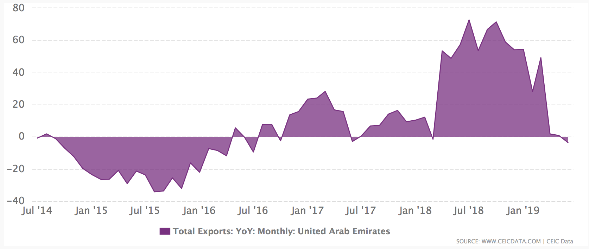
Fig.1.2 Total Export USD
Imports in the same year accounted for USD 213 billion, making it the world's 19 largest import economy. Jewelry, which accounts for 7.4 percent of total imports, plays an important role in the import item. Broadcasting equipment is the next most important item, which accounts for 6.07%(OEC - United Arab Emirates (ARE) Exports, Imports, and Trade Partners, 2020). The Arab Emirates imports quite a lot of products, which put them on 19th line in the international ranking. Imported products worth more than $70 billion are imported into the country every year. Cooperation with Asian and other countries in the UAE is mutually beneficial. Emirates supply there oil, petroleum products, precious metals, textiles and other goods and in return get what they need for normal life.
For example, Japan imports $25 billion worth of products to the UAE annually. The UAE government maintains close trade relations with China, importing clothes and textiles, copper, tin and other metals and food products from there. Negotiations have been held more than once at the level of the two countries' prime ministers, which should sooner or later lead to intensive cooperation between the two countries in pharmaceutical, telecommunications, high-tech, engineering and other spheres.
Not only friendly neighborly, but also trade relations are maintained by the Government of the Arab Emirates with Iran. However, so far, UAE's exports to this country significantly exceed imports. Iran buys so many Arab goods that 9 years ago an Iranian trade center was even opened in Dubai, which was to further strengthen commercial ties between the two countries.
Indian entrepreneurs have also entered the UAE market. Imports of such Indian goods as sportswear and equipment, pharmaceutical products are in the highest demand in the UAE. To bring more Indian businessmen to the Arab market, trade fairs are regularly organized.
The main European importer to the Arab Emirates is Great Britain. Spare parts for cars and planes, livestock products, clothing, electrical goods, equipment, household chemicals and precious metals are in great demand in Dubai and other emirates. The share of imported goods from the UK in the UAE market is increasing every year, while the rate of exports to the United Kingdom is steadily declining.
As a developed country, the United Arab Emirates imports and exports products worth tens of billions of dollars, being a major trading center not only in the Middle East, but around the world.
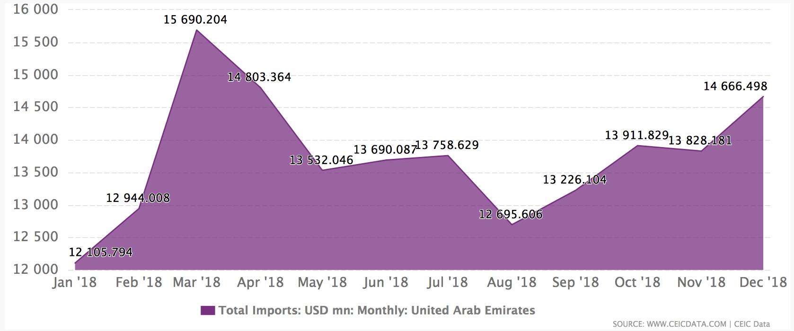
Fig.1.3 Total Imports USD
The UAE authorities are well aware of the need for serious protection of intellectual property and copyrights for business development in the country. Today, intellectual property protection in the United Arab Emirates is regulated by a whole package of laws, and the state is paying unprecedented attention to this issue in the Arab world. Compliance with the laws is also monitored by a special body, the Department of Copyright Protection. It worked very effectively: a significant number of complaints were dealt with promptly. In addition, the State independently initiates various inspections to detect violations. It should be noted that the penalties for such violations were very severe in the country and included sanctions up to imprisonment(Protection of Intellectual Property Rights in UAE, 2020).
1.4 Economical statistics
Considering statistics,consumer prices in the United Arab Emirates dropped 1.3 percent year-on-year in January 2020, following a 1.4 percent fall in the previous month. It was the thirteenth straight month of deflation, but the softest since May last year, as prices declined less for textiles, clothing & footwear (-7.0% vs -7.6%) while transport prices rebounded sharply (3.8% vs -0.8%), and education inflation accelerated (0.8% vs 0.7%). Meanwhile, cost continued to fall for: housing & utilities (-4.9%, the same pace as in in December 2019); food & beverages (-1.7% vs -1.1%); restaurant & hotels (-2.9% vs -1.3%); miscellaneous goods & services (-0.8% vs -0.1%); while furniture & household equipment dropped (-2.2% vs 1.4%). On the other hand, cost rose further for both recreation & culture (15.9% from 23.2%) and tobacco (6.2% from 6.4%).

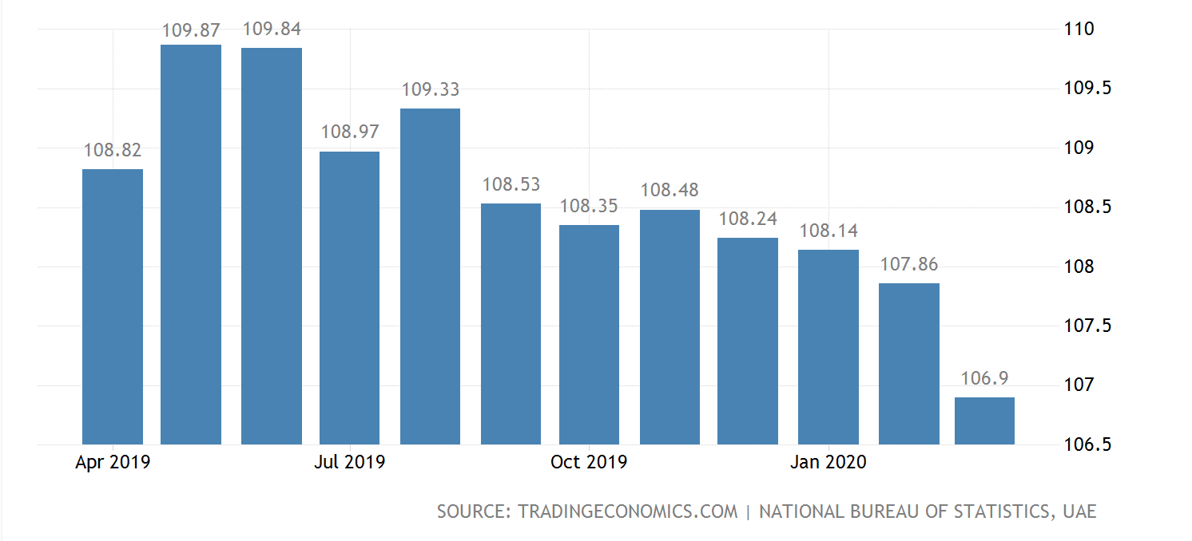
Consumer Price Index (CPI) Fig. 1.1
The UAE Gross Domestic Product volume grew to 425 USD billion in 2019. The maximum volume reached 425 USD bln, while the minimum volume was 2.85 USD bln(United Arab Emirates Inflation Rate | 1990-2020 Data | 2021-2022 Forecast | Calendar, 2020).
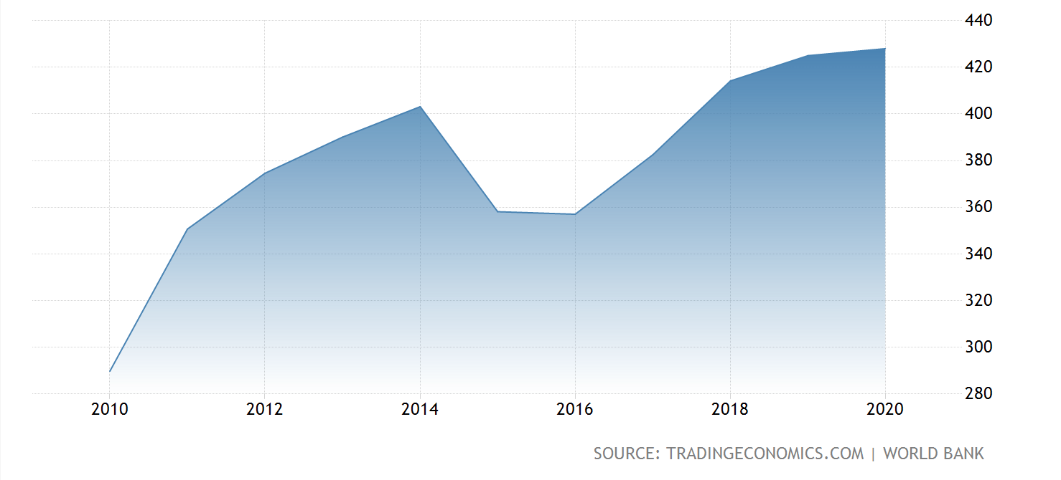
Fig.1.4 UAE GDP
The gross domestic product of the United Arab Emirates (in constant prices) will increase to AED 1.501 trillion (US$ 411 billion) in 2020, an increase of AED 37 billion (US$ 10 billion) from 2019, said Obaid bin Humeid Al Thayer, State Minister of Financial Affairs and Chairman of the Federal Tax Administration.
He noted that global economic factors, such as lower world oil prices, slower global economic growth, increased trade protectionism and the imposition of new economic sanctions, had an impact on GDP formation.
Nevertheless, the World Expo 2020, which will attract 25 million tourists, including 14 million international visitors, will contribute 1.5 percent to GDP in 2020. Responsible authorities will continue to support non-oil sectors of the economy.
The measures are already reflected in an increase in the number of jobs. Thus, private sector employment increased by 1 per cent in the second quarter of 2020. Jobs have increased in such sectors as tourism and real estate, while job losses have occurred in construction and manufacturing, as well as in the service sector.
Despite the fact that the effect of EXPO 2020 is still difficult to assess, the investment climate remains attractive. Thus, in the first half of 2019, the UAE attracted US$ 12.7 billion of foreign direct investment, with an average annual growth rate of 135%. Tourist flow increased by 3% over this period and amounted to 8.4 million tourists.
Moreover, in 2019 the UAE even produced more oil than a year earlier - 3.1 million barrels per day against 3 million barrels in 2018. The oil sector itself also grew by 2.5%, in contrast to other regions.

UAE would not be a safe haven for investors and would not be such a popular investment destination if it did not provide such great guarantees of its financial attractiveness and legal security. For example,monitoring and regulation of real estate transactions in Dubai is the responsibility of RERA (an agency established by the Emirate's governing bodies in 2007, just for this purpose). According to official sera data, Dubai's target deposits, as of April 2016, contained an amount of AED 29 billion ($7.9 billion), which clearly indicates a very high level of confidence in the Emirate's real estate market among investors({{Seo.OpenGraph.title}}, 2020). It states that investment in UAE is risk free.The UAE national currency dirham is "tied" to the dollar and is very stable. Since 1971, the rate of the dirham against the dollar has not changed. The cost of one US dollar is approximately 3.67 dirhams(Dollar to Dirham Exchange Rate, 2020). The interest rate of the UAE Central Bank is equal to 1.5%. The inflation rate for 12 months was 2.2%. (United Arab Emirates Inflation Rate | 1990-2020 Data | 2021-2022 Forecast | Calendar, 2020) Currently, the unemployment rate in the UAE among the local population fluctuates from 14 per cent, which is considerably lower in comparison to other Arab countries. However, the unemployment rate among women is considerably higher than that among men.
Thus, the UAE economy has recently been actively developing and the number of its stock market participants has expanded. Due to its financial policy and social and political stability, the UAE has become one of the world's largest financial centres playing an important role in global investment processes. Positive trends in economic development have created the basis for the establishment and development of sovereign wealth funds in thiscountry.Most foreign investors are attracted
-Location of the country: directly at the intersection of trade routes. The world's major capitals are located at approximately the same distance from the UAE.
-Absence of any income taxes, customs duties and other state fees.
-Cheap energy and business service.
-Large selection of qualified and not very skilled workforce, which can be paid much cheaper than in Europe and the United States.
-High level of confidentiality: all the papers that you send for inspection at business registration will not be made public.
-The possibility for foreigners to own the company on their own without involving local partners.
-Good transport connections: Most LEZs are nearby, or even in international ports and airports.
-Opportunity to conduct any kind of activity, except insurance and banking.
-With the opening of a company (even an offshore one), you get the opportunity to open an account in a reliable bank with high liquidity.
-Quite a quick check of all documents and relatively simple registration procedure.
-Your offshore company will not be treated with disbelief and suspicion, as it happens with companies registered in classical offshore jurisdictions.
-The UAE government's reluctance to share information about foreign businessmen working in their LEZ with the tax departments of other countries and the lack of leverage in the Emirates' leadership.
-The UAE government has signed an agreement according to which businessmen should not pay taxes twice from half a dozen countries.
-Stability of the state, both politically and economically.

The United Arab Emirates has a longstanding policy of attracting foreign investment. In terms of financial prospects, the absence of currency restrictions, combined with the possibility of capital and profit repatriation, as well as other positive aspects of the investment climate in the Emirates, which have already been described in this paper, characterizes the UAE as a solid platform for foreign investors.

SECTION 2
DEVELOPMENT OF AN INTERNATIONAL INVESTMENT PROJECT TO ESTABLISH A PARK IN UAE
In the south-eastern part of the Arabian Peninsula is the state of the United Arab Emirates. Its national borders are divided into three peninsula countries - the north-western border is with Qatar, the eastern part of the Emirates is bordered by the Sultanate of Oman and the southern part is bordered by Saudi Arabia.With its position between the Far East, Europe and Africa, the UAE has become an international economic centre. The impetus for economic development has been the development of oil fields and, of course, the creation of appropriate infrastructure - seaports, roads, airports, pipelines, power lines, etc. Transport transit infrastructure is particularly well developed, as evidenced by the presence of six international airports that allow passengers and cargo to pass through the country.
2.1 Legislative system and taxation
The political situation in the country fully reflects the lack of public influence on what is happening in the country. Thus, there are no parties and political associations in the UAE, as well as opposition branches of power. They are replaced by chambers of commerce and other specialized bodies related to business activities. The fact is that the places in them are formed quite democratically, because the capital of such chambers can be formed not only by local but also by foreign contributions. It is characteristic that such organizations spread their power mainly in the territories of free economic zones, although they can have a significant impact on the economic situation within each emirate.
Separate social classes are still forming in the UAE and local culture is constantly evolving. The European world has its own influence, contributing to the current lifestyle. The Emirates' authorities also favour such cooperation, creating maximum conditions for economic and business development.
Foreign investors in the UAE sometimes try to circumvent the 51% national ownership requirement by entering into additional agreements with local sponsors (so-called local partners). These agreements contain provisions that limit or exclude the powers and rights of the majority local owner, making the foreign party seem like the real owner of the business. According to some estimates, up to 85% of local LLCs in the UAE with foreign participation may currently operate under such additional agreements. In 2004, the Federal Council of the UAE tried to reduce this type of agreements by introducing Federal Law 17 of 2004 against the concealment of such agreements. This law would have rendered all such supplementary agreements null and void since it came into force in November 2007. The adoption of the Act was, however, postponed indefinitely by the Government to await other necessary legislative changes. This has certainly caused some discomfort among many foreign investors about their current agreements.
On April 31, 2015 the UAE passed a new Federal Law on Commercial Companies, which was designed to modernize the existing laws and cause markets to grow. More recently, the government has confirmed that the UAE is at an advanced stage of developing a foreign investment law that will allow full foreign ownership of business in certain sectors. There are factors that play a more important role than just economic. The UAE, like any country in the region, is concerned about economic growth, but the UAE certainly does not want growth at all costs. The legislative changes that are coming will be balanced with national and cultural interests, to increase the role of UAE's local citizens in their own country's economy, to recognize UAE's unique history and culture, to continue the Arab-Islamic roots of the Emirates. It should be noted that at present, the number of local citizens in the country is approximately 10% of the population. These principles were detailed in the UAE Vision 2021.
The United Arab Emirates, a country with a free trade area, offers 100% foreign ownership and zero taxes, which helps attract foreign investors. High oil revenues, strong liquidity, housing shortages and cheap credit in 2005-2007 led to a sharp rise in asset prices (stocks and real estate) and consumer inflation. As prices rise, transaction costs for business in the UAE increase, adversely affecting the welfare of government officials and other fixed-income individuals. Dependence on oil and a large number of expatriate workers pose significant long-term challenges to the UAE. The UAE's strategic development plan for the next few years focuses on diversifying the economy and creating more opportunities for citizens through better education and more jobs in the private sector.
All companies in the UAE can be divided into onshore, which are allowed to operate in the UAE, and offshore, which are prohibited from doing business in the Emirates.
The most popular on-shore legal forms are the following:
1) Limited Liability Company (LLC) (registered in partnership with a UAE citizen in the Emirate, where the UAE citizen owns 51% of the company's shares)
2) Free Zone Company (100% foreign ownership)
3) Sole Proprietorship (the company is registered in the Emirate, but 100% of the capital can be owned by a foreign person. It is important to note that in this case the liability is unlimited, i.e. if the company is in debt and there are not enough assets of the company to pay it off, the missing funds will be found from the personal assets of the company owner).
4) Freelancer License (permits are issued by a number of free economic zones)
Offshore companies, whose activity in the UAE is markedly limited, are no less in demand.
1) Offshore companies (may not conduct business in the UAE and rent an office for this purpose. They are holding companies that manage assets, invest in business and acquire real estate.
The peculiarity of our choice is that in our case it is impossible to do business without the involvement of a local owner or UAE citizen. Federal Law 2 of 2015 is the new Commercial Companies Act (CCL), which came into force on July 1, 2015 and replaced the previous Commercial Companies Act (Federal Law 8 of 1984, as amended). Foreign enterprises wishing to operate within the UAE usually do so either through a Limited Liability Company (LLC) form, an equivalent of a LLC, or through a branch/representative office, although the new CCL does allow for other forms of companies that may be incorporated in the UAE.
2.2 Environmental benefits of the project
Since the climate of the country is very hot and dry, The United Arab Emirates can safely be called a real oasis, situated in the middle of hot and dry desert. The Government has always supported, and sometimes initiated, a variety of programmes aimed at greening the country and thereby improving its urban landscape. It is not difficult to understand that trees in countries such as the UAE are highly valued because of the area's characteristics. Gardening in the Emirates is a very important environmental project that is being carried out to ensure the preservation of the unique natural coastal landscape. At the same time, specialists and experts agree that the flora of the Arab Emirates, in particular mangroves, can preserve the ideal state of the coastal ecological system. Thus, it has a significant impact on slowing down global climate change processes.
Greening programmes are never wasted; they are carried out in the regions most in need of greening, with clear and gradual plans. These plans are developed by special governmental bodies responsible for gardening and public parks. In Dubai, gardening is fully supported and protected at the state level. At the legislative level, for example, there are significant monetary penalties for damaging and destroying flower and other green spaces. Sufficiently expensive maintenance of each tree brought in and flower planted requires public authorities to make every effort to protect and preserve park areas and flower beds.
Official government agencies encourage local people to fight vandals together. In their view, the people of Dubai must be aware and understand that the State spends huge sums of money to bring various trees and flowers into the Emirates and decorate the streets with them.
The total amount of fines for damaging the city's flower plantations can be as high as Dhs1000. There are no discounts or benefits for age or other categories. The laws of the Emirates equate the spoiling of flowers with the spoiling of public property and consider such acts criminal.
The State bodies responsible for public parks and gardening in the Emirates develop and draw up clear programmes for the gradual greening of the Emirates. In the course of thorough studies, the areas and streets of the city to be landscaped are identified.
The Dubai authorities are also actively pursuing a policy of increasing the total area of green spaces in the city. The Municipality of Dubai views the provision of an average of 24 square metres of green space per capita as an effective result. In Dubai, green spaces are also extensive and grandiose. Currently, all suburban areas and resort areas are being actively landscaped. The modern city of Dubai is a real green island in the middle of a golden desert.
Dubai is rightly called the Eastern fairy tale in the middle of the desert. Despite the hot climatic conditions in this region, there are always green tree crowns and a variety of fragrant flowers. The greenery of Dubai, like everything in this city, is festive and vibrant. Throughout the city you will see numerous flower beds and plantings. Taking care of flowering plants in the heat of the desert is not easy enough.
Every flower bed, every palm tree brought from abroad and carefully planted in Dubai requires maximum care. You will be amazed at the diligence and care with which the green spaces are cared for here. Each tree has its own personal watering system.
On the outskirts of the city you can see numerous municipal greenhouses, which grow flowers for city clubs. Annually, the total area of such greenhouses increases by 10% on average. Moreover, these greenhouses grow not only flowers and plants for greenery, but also medicinal herbs. And students and researchers conduct scientific experiments and experiments in greenhouses. More than two thousand employees take part in the improvement and landscaping of the city.
In Dubai, planting greenery is a true national pride. Green spaces and flowers are planted everywhere, in parks, near mosques, schools, public and government buildings and even along roads.
For our park we chose a location in Dubai, because today it is a city that attracts a large number of tourists. Dubai's market is very young, so many niches are free or there is little competition. The continuous development of the country is another factor that puts Dubai in the top 10 and safest countries for investment. Many foreign nationals are eager to come to the Emirates not only to live, receive high quality education, but also to work and do business.
2.3 Opening a business
Let’s discuss what you have to do in order to start a business in UAE:
To start with, you should choose the right type of licence in relation to the company's activities, the acceptable ownership and location of the company. In the United Arab Emirates, there are three types of business licences for all types of companies: commercial (for all types of trade), manufacturing (for manufacturing or industry) and service (for services), as well as two types of property, involving the independent conduct of business or the establishment of a company with a local partner. In the latter case, the share of local capital is at least 51% in any commercial company. In case with opening a park we’ll need a service license.
Dubai has the largest number of free economic zones. Their number exceeds 20,the original idea behind the creation of free economic zones in the UAE was to create the conditions for a certain type of business activity. For example, the Dubai Multi Commodities Centre (DMCC) was created purely for the exchange of goods and trade, and the Dubai International Financial Centre (DIFC) was created to deal with financial instruments. After several years, the Free Economic Zones (FEZs) decided not to limit their range of potential clients-companies. Now Dubai Multi Commodities Centre (DMCC) can open a shop, clinic, beauty salon and more. Thus, when choosing a free economic zone, one should not pay close attention to its name. If you want to register your company there, you should check with your local management. Some free economic zones willingly add new activities to their lists, if it does not generally contradict the very idea of a free economic zone.Although free zones allow 100% foreign ownership, companies established in the free zone are not allowed to operate within the UAE. Each Free Zone has its own (non-criminal) laws which apply to companies located there, together with UAE Federal Laws and local laws in the respective Emirate. The DIFC is the only exception to this because it has its own set of laws (other than criminal laws) which are not administered by UAE laws. Generally, each free zone allows the registration of a company, branch or representative office in its jurisdiction.

It is possible to register a branch office in the Free Zones. A branch is the same as a branch within the UAE, a branch is an extension of a foreign parent company and therefore is not a separate legal entity and does not carry limited liability. A branch is also not required to have its own share capital. The main difference between a local UAE branch and a Free Zone branch is that the Free Zone branch does not need to appoint a national service agent. However, the branch office is limited in what it can do and is only involved in activities that coincide with those of its foreign parent.
The UAE is an extremely convenient country for doing business. The first and main advantage of the state is its tax-free environment. It is very convenient for entrepreneurs to do business in one of the free economic zones of the country. Free economic zones are not subject to income and corporate taxes, interest and dividend taxes as well as import and export taxes.

The only exceptions are companies doing business in the oil or gas industry or banks operating on the local market. Employees of companies, as well as private individuals residing in the UAE, are not subject to tax.
There are no taxes in the United Arab Emirates. If you start a company, it is only your responsibility to pay the annual license fee, which varies from free economic zone. However,from 1 January 2018, 5% VAT was introduced in the UAE. At the same time, there is no tax on personal income, corporate income and dividends.
Having a registered company address is one of the key conditions for obtaining a license. To obtain the address, the business owner can rent an office, enter into a lease agreement for premises in the business centre or rent a workstation (Flexi-desk) from the free economic zone. Flexi-desk is a workstation in the free economic zone business center that is available for use for 16-20 hours per month. At the same time, the cost of renting a Flexi-desk is 3-6 times less than the cost of a year's rent of an office, which is the best solution for a start-up business.
The list of documents required to start a company depends on the following factors:
-Who will be the shareholder of the company (natural person or legal entity) and how many shareholders will own the company,
-A new company will be opened or it will be a branch or subsidiary.
In the case of legal persons and the opening of a branch or subsidiary, duly certified/legalized corporate documents will be required.
Upon incorporation of the company in Dubai or another emirate, the owner of the company receives the following documents (please note that the names of the documents may vary depending on the free economic zone):
-Certificate of Registration / Incorporation;
-License ;
-Company Charter (Memorandum and Articles of Association / Articles of Incorporation);
-Share certificate.

SECTION 3: FINANCIAL PLAN AND CALCULATIONS
Now let’s conduct calculations of expected income with market analysis and investment attractiveness assessment.
3.1 Determining location of a project and its benefits
The park is going to be located on a territory of “Dubai Parks and Resorts”. Dubai Parks and Resorts is a huge entertainment complex of over 285 hectares, located on the outskirts of Dubai near the artificial island of Palma Jebel Ali. Dubai Parks and Resorts consists of several different entertainment parks. Attendance statistics of this complex for 2019 was about 3mln. In comparison with the previous years (Table 3.1),the park's attendance is increasing every year.
Dubai Parks and Resorts attendance Table 3.1
 | 2017 | 2018 | 2019
Peoplevisited | 2.300.000 | 2.800.000 | 3.000.000
As Dubai is planning to host a large number of events, exhibitions (such as Expo 2020), various festivals and competitions in the next 5 years. Consequently, the flow of tourists is expected to increase, which will lead to greater attendance at parks, including Dubai Parks and Resorts.
Now let’s consider all the expenses we might have at the beginning of our development.(Table 3.2)
Approximate cost of company incorporation is $5000. This price includes: mandatory registration of the name, license, opening a bank account, your visa for 3 years, sponsor services, office space, payment of utilities, WIFI.
3.2 Estimated calculations of costs,wages and income of the project
For our case, the type of ownership in UAE that is called a musataha is suitable. Musataha is a right in rem conferring upon the owner thereof the right to build a building or to plant on the land of another. The DLD registration fee payable on a Musataha agreement is 1% of the total annual rent. For our park we are going to rent 2000 sq m which will cost us $10 per 1 sq m. And the total monthly rental price for us will be $20.000 and annual will be $240.000. And if to consider Mustaha agreement fee we will have to pay $2.400. The price for construction works including irrigation system,lightsystem,park layout, host construction,as well as recreation areas and photo zones will be $1.000.000. Purchase of plants for landscape design will cost $500.000.
Initial costs Table 3.2
Investments | $Price
Companyincorporation | $5.000
LandRenting | $20.000
Agreementfee | $2.400
Constructionworks | $1.000.000
Purchaseofplants | $500.000
TOTAL | $1.527.400
Then we need to consider monthly expenses(Table 3.4). There are going to be 38 employees and 7 job titles. First position is a Director, he is working for 9 hours and gets $20/1h. Which means he will be getting $180 per day, per month he will be getting $4.500 with 25 working days.
Second position is managers, we will need 8 managers:financemanager,marketingmanager,advertisementmanager,HR manager, development manager,brandmanager,purchase manager and account manager. They will have the same working schedule as the director,but with $15/1h, one manager will be getting $135 per day and $3.375 per month with 25 working days and totally for all managers it will be $27.000/1 month .
Third position is gardeners, we will need 10 employees, with the same schedule of 9 hours and $6/1h => $54/1 day => $1.350/1 month => totally for all gardeners $13.500/1 month.
Fourth position is cleaning personnel,we will need 6 people. They will get $4/1h with 9 working hours they will get $36/1 day => $900/1 month=> totally for all staff $5.400/1 month.
Fifth position is security, we will need 5 people. They will get $5/1h with 9 working hours they will get $45/1 day => $1.125/1 month => totally for all staff $5.625/1 month.
Sixth position is maintenance personnel,such as electricians and plumbers, we will need 4 people. They will get $4/1h with 9 working hours they will get $36/1 day => $900/1 month => totally for all staff $3.600/1 month.
Seventh position is cashiers,we will need 4 people. They will get $5/1h with 9 working hours they will get $45/1 day => $1.125/1 month => totally for all staff $4.500/1 month.
Totally on salaries we will spend $64.125 per month(Table 3.3)
Due to inflation Total Payroll for 2021 is going to change:
TP2021 = TP2020+TP2020 x i (inflation rate)
Presumably inflation rate in UAE for 2021 is predicted to be 1.5%
=> TP2021 = $769.500 + $769.500 x 1.5% = $781.042
Staff wages Table 3.3
Position | Numberofemployees | Wageperday | Wagepermonth | Wageperyear
Director | 1 | $180 | $4.500 | $54.000
Managers | 8 | $1.080 | $27.000 | $324.000
Gardeners | 10 | $540 | $13.500 | $162.000
Cleaningpersonnel | 6 | $225 | $5.400 | $64.800
Security | 5 | $225 | $5.625 | $67.500
Maintenancepersonnel | 4 | $144 | $3.600 | $43.200
Cashiers | 4 | $180 | $4.500 | $54.000
TotalPayroll 2020 | 28 | $2574 | $64.125 | $769.500
TotalPayroll 2021 | 28 | $2612 | $65.086 | $781.042

Considering the cost of water and electricity.Average water price is $2 per 1 cubic meter, we will need 20 cubic meters per day,it will cost us $40, which means we will need to pay approximately $1200 per month. Average price per kilowatt is $0.024,the consumption of the park per month is 20.000 kW,which means we will have to pay $480 per month for electricity. Monthly expenses for updating flower expositions will be $10.000. And in case of unforeseen expenses we will leave $10.000 per month. Transportation costswillbe $2.000.
Monthly and annual expenses Table 3.4
Name | Expensespermonth | Expensesperyear
Salaries | $64.125 | $769.500
LandRenting | $20.000 | $240.000
Utilityservices | $1.680 | $20.160
FlowerExpositions | $10.000 | $120.000
Amortization | $10.000 | $10.000
Transportation | $2.000 | $24.000
Technicalsupplies | $2.000 | $24.000
Advertisement | $3.000 | $36.000
Total | $112.805 | $1.353.660
The next step is to consider the expected turnover(Table 3.5). In our case, the estimated turnover will consist of the following items:
- Cost of entrance tickets. Given the attendance statistics of the complex and given the area of our park, it is possible that the approximate number of people visiting the park per day will be 300. During the high tourist season (October to April) the expected attendance will be 500. The estimated ticket price will be $8. Which means that we will earn $2.400 if the attendance is 300 people and we will earn $4.000 if the attendance is 500 people.
- Leasing out the area for the food zone.The size of the allocated areas for rent is 400 sq m Price will be $60/ 1 sq m per one month. In case if we will rent out all 400 sq m we will get $24.000 per month.
- Table 3.5
ExpectedTurnover
Name | Price | Permonth | Peryear
TicketsCost | $8 for 1 person (incl. 5% VAT) | $72.000 - 300 ppl  $120.000 - 500 ppl | $1.200.000
Leasingout | $60 for 1 sq m | $24.000 | $288.000
Total |  | $96.000 - 300 ppl  $144.000 - 500ppl | $1.488.000

The interest rate in UAE is 1.5%, inflation rate is 2.2%,risk rate is 4%.Now we need to calculate the deposit rate :
i = (1 + 1.5%) * (1 + 2.2%) * (1 + 4%) - 1 = 1.015 * 1.022*1.04 = 1.079%
3.3 Projects efficiency
Now we need to determine investment efficiency (Table 3.6)

Table 3.6
Investmentefficiency
 | Year | Year
Indicators | 0 | 1 | 2 | 3 | 4
Investment $ | $1.527.400 | - | - | - | -
Annualincome $ | - | $1.488.000 | $1.848.000 | $2.664.000 | $2.664.000
VAT @ 5% |  | $74.400 | $92.400 | $133.200 | $133.200
Annualcosts $ | - | $1.353.660 | $1.406.364 | $1.434.491 | $1.463.181
NetProfit $ | - | $59.940 | $349.236 | $1.096.309 | $1.067.619

Now we can predict a forecast for 2021,the inflation rate this year is predicted to be 1.5%,so our expenses will grow.
$1.353.660 x 1.5% = $1.373.964
We are planning to have 100 more people coming to our park per day,which will be 400 people during non-touristic season and 600 during the period from October till April,as there is some customer loyalty since year 2021 we will increase our ticket price to $12 (incl. 5% VAT), that will bring us $360.000. Which will make of annual income.
It means that the net profit will be:$1.848.000 - $1.406.364 -$74.400 = $349.236
Then we can also predict a forecast for 2022,let’s assume that the inflation rate will be 2%,then our expenses will be:
$1.406.364 x 2% = $1.434.491
In 2022 we are planning to increase the attendance of our park to 500 people per day during non-touristics season and 700 during the period from October till April. Which will bring us $2.664.000 of the annual income.
$2.664.000 - $1.434.491 - $133.200 = $1.096.309 - net profit
In 2023 the inflation rate will not change,so expenses for this year will be:
$1.434.491 x 2% = $1.463.181
As we will be reaching the limit of the maximum capacity allowed by health and safety regulation, we assume the number of visitors to stay the same as in previous year. So,the annual income will stay at $2.664.000.
Proceeding with calculations, let us calculate the discount rate:
Discount rate for the first year: 1 /1.079 = 0.92%
Discount rate for second year: 1 /1.186 = 0.84%
Discount rate for third year: 1 / 1.304 = 0,76%
Discount rate for fourth year: 1/ 1.434 = 0.70%
Now let’s calculate cash flows:
Cash flows = depreciation + net income.
=> Cash flow for the first year: $10.000 +$59.940 = $69.940
Cash flow for second year: $10.000 + $349.236 = $359.236
Cash flow for third year: $10.000 + $1.096.309 = $1.106.309
Cash flow for fourth year: $10.000 + $1.067.619 = $1.077.619
Discounted cash flows = cash flows x discount rate
Discounted cash flow for the first year:$69.940 x 0.92% = $64.345
Discounted cash flow for second year: $359.236 x 0.84% = $301.758
Discounted cash flow for third year:$1.106.309 x 0,76% = $840.795
Discounted cash flow for fourth year: $1.077.619 x 0,70% = $754.333
To determine if a project is successful, the measurement of its net present value (NPV), payback period, and profitability index is important.
NPV = the sum of Discounted Investment Cash Flows.
NPV = ( $64.345 + $301.758 + $840.795+$754.333) - $1.527.400 = $433.831
Since NPV>0, then the project will be recommended for investment according to this indicator.
Now we can calculate the index of profitability (PI), which is characteristic of the investment efficiency. The higher the number, the more appropriate the project would be.
To calculate the PI we will need to divide discounted cash flow by investments:
PI =$1.961.231/ $1.527.400 = 1.28
We can see that PI>1 which means that this project should be accepted.
Now let’s calculate the Payback Period(PP) of our park, it is an investment divided by the average annual discounted income.
PP = 2 + ($1.098.224/$1.106.309) = 2.99
It means that the project will pay back in less than 3 years which makes this project efficient,reliable and profitable.

CONCLUSION
In conclusion, I think it is important to say that it is necessary to do a very precise and unfolded research before making a decision whether to invest in a project or not. In order to speed up the decision of the investor on whether to invest in a particular enterprise, it is necessary to draw up an investment project that defines the goal that the firm seeks to achieve, a business strategy in conjunction with the timing of achieving the goal.
As you already know, Dubai attracts people from all over the world, offering a luxury lifestyle. Magnificent skyscrapers, endless shops and restaurants, low crime rates, excellent roads and high returns on investment are just some of the main aspects that make people from all over the world choose Dubai for investment, including real estate. Investing in real estate in Dubai will be profitable as there is no need to pay annual property tax in Dubai. Once the property is purchased or rented and the registration fees are paid, no additional or recurring taxes are required. In addition to the fact that when investing in real estate in Dubai, the investor can save money that he would have spent on property taxes elsewhere, when investing in real estate in Dubai, the investor benefits from low acquisition costs.
The businesses in Dubai and the United Arab Emirates attract the attention of a large number of entrepreneurs, businessmen and investors from all over the world as there are no taxes on income, personal profits or dividends in the UAE. Which makes it a perfect country for investing. After all the calculations done we can see that establishment of a park is a very profitable business to run in Dubai,mostly because this city is one of the most popular tourist destinations. And all the indicators such as NPV and PP showed that this project should be accepted. Summing up all the above, we can agree that this country is totally worth doing business in since it has all the right conditions and opportunities for investors and for conducting a successful business.

References:
1.Facts, W., 2020. The World’S Largest Oil Reserves By Country. [online] WorldAtlas. Available at: <https://www.worldatlas.com/articles/the-world-s-largest-oil-reserves-by-country.html> .
2.Worldpopulationreview.com. 2020. [online] Available at: <https://worldpopulationreview.com/countries/united-arab-emirates-population/>.
3.2020. [online] Available at: <https://santandertrade.com/en/portal/establish-overseas/united-arab-emirates/foreign-investment>.
4.Map, W. and Facts, W., 2020. United Arab Emirates Time Line Chronological Timetable Of Events - Worldatlas.Com. [online] Worldatlas.com. Available at: <https://www.worldatlas.com/webimage/countrys/asia/uae/aetimeln.htm>.
5.The United Arab Emirates. 2020. History. [online] Available at: <https://unitedarabemiratesun.weebly.com/history.html>.
6.Hbs.edu. 2020. [online] Available at: <https://www.hbs.edu/faculty/Publication%20Files/FDICapital_Formatted_20170922_Final_W_c7fcb82c-f318-4632-a589-20118eaeebf8.pdf>.
7.Wto.org. 2020. World Trade Organization - Global Trade. [online] Available at: <https://www.wto.org/>.
8.MSD, 2020. WTO AGREEMENTS. [online] Slideshare.net. Available at: <https://www.slideshare.net/kranthikumaramity/wto-agreements>.
9.Pkf.com. 2020. [online] Available at: <https://www.pkf.com/media/10038961/free-zones-v5-digital.pdf>.
10.TenTwenty | Webdesign, W., 2020. DIFC Laws & Regulations | Dubai International Financial Centre (DIFC) | Difc.Ae. [online] Dubai International Financial Centre (DIFC). Available at: <https://www.difc.ae/business/laws-regulations/>.
11.Bakermckenzie.com. 2020. [online] Available at: <https://www.bakermckenzie.com/-/media/files/insight/publications/2017/05/doingbusinessuae/bk_uae_dbi_2017.pdf?la=en>.
12.santandertrade.com. 2020. [online] Available at: <https://santandertrade.com/en/portal/establish-overseas/united-arab-emirates/tax-system>.
13.Uk.practicallaw.thomsonreuters.com. 2020. [online] Available at: <https://uk.practicallaw.thomsonreuters.com/w-007-8222?transitionType=Default&contextData=(sc.Default)&firstPage=true&bhcp=1>.
14.Doingbusiness.org. 2020. Dealing With Construction Permits Reforms - Doing Business - World Bank Group. [online] Available at: <https://www.doingbusiness.org/en/data/exploretopics/dealing-with-construction-permits/reforms>.
15.Mpra.ub.uni-muenchen.de. 2020. [online] Available at: <https://mpra.ub.uni-muenchen.de/84584/1/MPRA_paper_84584.pdf>.
16.Workman, D., 2020. World’S Top Export Countries. [online] World's Top Exports. Available at: <http://www.worldstopexports.com/worlds-top-export-countries/>.
17.Economy.gov.ae. 2020. [online] Available at: <https://www.economy.gov.ae/Publications/UAE%20Imports%20and%20Exports%20Guide.pdf>.
18.Oec.world. 2020. OEC - United Arab Emirates (ARE) Exports, Imports, And Trade Partners. [online] Available at: <https://oec.world/en/profile/country/are/#Exports> .
19.Intellectual Property. 2020. Protection Of Intellectual Property Rights In UAE. [online] Available at: <https://adamip.com/blog/ip-in-general/your-intellectual-property-rights-protection-in-uae/> .
20.Tradingeconomics.com. 2020. United Arab Emirates Inflation Rate | 1990-2020 Data | 2021-2022 Forecast | Calendar. [online] Available at: <https://tradingeconomics.com/united-arab-emirates/inflation-cpi>.
21.Legal Advice Middle East. 2020. {{Seo.Opengraph.Title}}. [online] Available at: <https://legaladviceme.com/legislation/112/uae-law-16-of-2007-establishing-real-estate-regulatory-agency>.
22.Exchangerates.org.uk. 2020. Dollar To Dirham Exchange Rate Today, Live 1 USD To AED = 3.67 (Convert Dollars To Dirhams). [online] Available at: <https://www.exchangerates.org.uk/Dollars-to-Dirhams-currency-conversion-page.html>.
23.Theodora.com. 2020. United Arab Emirates Economy 2020, CIA World Factbook. [online] Available at: <https://theodora.com/wfbcurrent/united_arab_emirates/united_arab_emirates_economy.html> .
24.U.ae. 2020. Economy - The Official Portal Of The UAE Government. [online] Available at: <https://u.ae/en/about-the-uae/economy>
25.Tradingeconomics.com. 2020. United Arab Emirates - Economic Forecasts - 2020-2022 Outlook. [online] Available at: <https://tradingeconomics.com/united-arab-emirates/forecast> .
26. Nyulawglobal.org. 2020. A Guide To United Arab Emirates Legal System - Globalex. [online] Available at: <https://www.nyulawglobal.org/globalex/United_Arab_Emirates.html>
27. Photius.com. 2020. United Arab Emirates Executive And Legislative Branches - Flags, Maps, Economy, History, Climate, Natural Resources, Current Issues, International Agreements, Population, Social Statistics, Political System. [online] Available at: <https://photius.com/countries/united_arab_emirates/government/united_arab_emirates_government_executive_and_legisl~6.html>.
28.Emirates, S., 2020. Steps To Start A Business In The United Arab Emirates. [online] Shuraa Business Setup. Available at: <https://www.shuraa.com/blog/2018/11/steps-to-start-a-business-in-the-united-arab-emirates.html> .
29.Dubaiparksandresorts.com. 2020. Theme Park In Dubai | Dubai Parks And Resorts. [online] Available at: <https://www.dubaiparksandresorts.com/en>.
30.2020. Investment Projects Evaluation. [online] Available at: <https://www.researchgate.net/publication/228642442_Investment_projects_evaluation_by_simulation_and_multiple_criteria_decision_aiding_procedure.
31.U.ae. 2020. Investment Authorities And Schemes - The Official Portal Of The UAE Government. [online] Available at: <https://u.ae/en/information-and-services/finance-and-investment/investment-schemes
32. Studio, C., 2020. UAE International Investments. [online] Uii.ae. Available at: <http://www.uii.ae/>
33. Loan, M., Us, C., Us, A., us, C., Account, B., Loan, M., Account, B., Loan, M. and Invest?, I., 2020. Investments In The UAE: Why Investing Is Important & Where To Invest?. [online] Policybazaar. Available at: <https://www.policybazaar.ae/investments-in-the-uae-why-investing-is-important-and-where-to-invest-ipart/>

