ALFRED NOBEL UNIVERSITY

DEPARTMENT OF GLOBAL ECONOMY

Bachelor’s Thesis

___________________________________________

DEVELOPMENT AND IMPLEMENTATION OF THE
INTERNATIONAL INVESTMENT PROJECT’’STARTING A PHARMACEUTICAL COMPANY IN SINGAPORE’’
___________________________________________

Student: ___Wejden Hakiri_______________
Group: _________Mev16 English__________
Specialty: 292 International economic relations
Supervisor: _I. Shkura, Ph.D, assoc. prof_____
Last name, initials, scientific degree

Dnipro, 2020

ALFRED NOBEL UNIVERSITY
DEPARTMENT OF GLOBAL ECONOMY

First (bachelor) level
Specialty 292 International economic relations
Approved by:
Head of the Department _________________
_____________________________________
____________________________________
(signature, last name, initials, scientific degree, academic status)

“____” __________________20__ р.

The Bachelor’s Thesis
Assignment
_____________________________________________Wejden Hakiri_______________________________________
Student’s full name
1. Title ____Development and implementation of the international investment project ‘’ starting a pharmaceutical company in Singapore ‘’__________________

2.Supervisor___ I. Shkura, Ph.D, assoc. prof _______________________________

__________________________________________________________________________________________
(last name, initials, scientific degree, academic status)

Approved with the Order of «___" _____________ 20___, No. _______________
3. Deadline for submission ___________________________________________________________________
4. Aim of the paper Investigate the feasibility of stating a pharmaceutical company in Singapore ‘’_________________________________________________________
5. Thesis outline (list of issues to be developed):

- _Analyze the Singaporean economy: its current situation and major challenges
- Analyze the foreign economic activity of the country_
- Assessment of the project : calculation of the economic ratio and index necessary to evaluate the profit of the project ______________________________________________________________________________________________________________________________________________________________________________________________________________________________________________________________________________

6. Date of issue of the assignment ______________________

7. Thesis schedule
no | Stages | The deadline for submission
no | Stages | Schedule date | Actual date
1 | Chapter 1
2 | Chapter 2
3 | Chapter 3
4 | The whole paper

Student _________ _________________________
signature last name, initials

Supervisor _________ __I.Shkura_____________________
signature last name, initials
Анотація

У цьому дипломі досліджується доцільність міжнародного інвестиційного проекту "Запуск фармацевтичної компанії в Сінгапурі". Цей інвестиційний проект розроблений за рахунок іноземного інвестора з Об'єднаних Арабських Еміратів, зокрема для Дубая.
Сінгапур поставив своєю основною метою стати глобальним біомедичним центром. Незважаючи на те, що інші країни мають потенціал розвивати свою біомедичну галузь, Сінгапуру вдалося стати основним напрямком цієї галузі в Азіатсько-Тихоокеанському регіоні. Виходячи з цих фактів, ми розробили спеціальне дослідницьке запитання: «Що призвело до залучення інвесторів до біомедичної промисловості Сінгапуру?». І чи можливо створити фармацевтичну компанію в цьому напрямку та особливо в цей час?
Мета цього дослідження - з’ясувати доцільність цього міжнародного інвестиційного проекту щодо запуску фармацевтичного препарату та які основні чинники враховують інвестори, вирішуючи, куди інвестувати.
Попередній етап дослідження - повний аналіз сингапурської економіки та її зовнішньоекономічної діяльності та конкретний розрахунок для надання прозорих даних.
Перший етап нашого дослідження включав переважно вторинні дослідження, які надають основну інформацію про економіку Сінгапуру, біомедичну галузь Сінгапуру, а також про загальний інвестиційний клімат країни.
Результати вражають, і дослідження, яке було проведено, стане великим надбанням та надзвичайно цінною інформацією та аналізом для уряду, інвесторів, а також приватних дослідників.
Ключові слова; інвестиційний проект, економіка Сінгапуру, біомедична промисловість

Abstract

This paper investigates the feasibility of the international investment project ‘’starting a pharmaceutical company in Singapore ‘’. This investment project is developed at the expense of foreign investor from United Arab of emirates to be specific from Dubai.
Singapore has made it its fundamental goal to become a global biomedical hub. Despite other countries having a potential to develop their biomedical industry, Singapore has managed to become a primary destination for this industry in Asia-Pacific region. Based on these facts, we have developed a special research question which is “What has led investors to be attracted to Singapore’s Biomedical Industry?”. And is it feasible to start a pharmaceutical company in this destination and especially at this time?
The purpose of this research is to find out the feasibility of this international investment project of starting a pharmaceutical and what are the main factors that investors take into consideration while deciding where to invest.
Through the progress of thesis, we tried initially to provide a full analysis of the Singaporean economy and its foreign economic activity and to provide a concrete calculation in order to provide transparent data.
the first phase of our research involved mainly secondary research, that provides background information for the Singaporean economy, Singapore’s Biomedical industry but also on the overall investment climate of country.
The findings are impressive and the investigation that was undertaken will be a great asset and extremely valuable information and analysis to the government, investors as well as private researchers.
Keywords; investment project, Singaporean economy, Bio medical industry

TABLE OF CONTENT

INTRODUCTION……………………………………………………………6
SECTION 1. SINGAPOREAN ECONOMY: THE CURRENT SITUATION,
DEVELOPMENT TRENDS AND MAJOR PROBLEMS………………….9
1.1. General characteristics of the development of the Singaporean economy since the 1970’s ………………………………………………………………………………9
1.2. The structure of the ‘’MONACO OF THE EAST’’ economy and its path towards the current situation …………………………………………………………16
1.3. Main difficulties that faces the Singaporean economy …………………..18
SECTION 2. FOREIGN ECONOMIC ACTIVITY OF SINGAPORE:
INTERNATIONAL GOODS AND CAPITAL MOVEMENT ……………20
2.1. Export-import activity of Singapore………………………………………..20
2.2. The scope and main directions of foreign direct investment in Singapore…..24
2.3. Assessment of Singapore investment climate and the degree of its
attractiveness to international investors ……………………………………….25
SECTION 3. DEVELOPMENT OF AN INTERNATIONAL
INVESTMENT PROJECT TO ESTABLISH A PHARMACEUTICAL COMPANY …………………………………………………………………………29
3.1. Analysis of the Biomedical industry in Singapore…………………………29
3.2. Feasibility analysis of the creation of pharmaceutical company as an investment Project, Evaluation of the need for investment resources …………………35
3.3. Profit estimation and a deep assessment of the economic…………………..36
attractiveness of the investment project.
CONCLUSIONS AND PROPOSALS……………………………………….43
REFERENCES…………………………………………………………………45

INTRODUCTION

As economies around the world are suffering from the impact of Covid-19, businesses are experiencing losses, workers are without jobs, and many faces the challenge of a complete upheaval of lifestyle. However, pharmaceutical companies taking center stage in the Covid-19 fight, are seeing positive growth on the stock market and a new burst of innovation in the infectious disease landscape as the race for treatment approval for a Covid-19 therapy takes off.
Covaid 19 has changed the world dramatically, a lot of pharmaceutical companies are looking for a vaccine or a treatment for this disease that literally paused the world for over 3 months now and is still putting everything in hold. In this context, the idea popped up to use it in my final thesis’’ starting an international investment project ‘’ and that is how the idea of to start a pharmaceutical company. The choice of the country of establishment wasn’t a random choice but in fact a deliberate one. This country is the smallest country in the east of Asia with a size of 684 square kilometers, this miracle country has managed to become an icon for development and especially in the field of medicine and biotechnology.
Here is a brief introduction about the history of Singapore, after the British colonization, and to be more specific in 1970 the Singaporean economy has experienced a significantly amazing development and reached a remarkable peak. In fact, Singapore is known as the Monaco of the east, a country with limited resources and a dark history that has managed to rank in the top developed countries.
Digging deep into history the country in the 1960's was undeveloped and very poor and in pathetic conditions, now it is one of the fastest growing economies around the world. This miraculous country has managed to overcome the lack of natural resources to embrace Globalization, free market capitalism, Modern education and wisely oriented policies. This country keeps surprising the world by almost ranking each and every global ranking.
Singapore has a high R&D cost and lack of long-term support in terms of funding, yet it has managed to attract several global biomedical companies. We are keen to inquire about the reason behind investor’s incentive to Singapore’s biomedical industry, as well as the opportunities and challenges that stakeholders face. Singapore is known for being a global business and financial hub, despite being one of the world's smallest countries. In addition, its economy is recognized as the world's most competitive and business friendly economies. Manufacturing and services are the primary sector of Singapore's economy that helps in further sustainability and development of the country. The biomedical industry in Singapore has a high potential and that's one of the main reasons for local and foreign investor's attraction.
The country's fair and competitive market place, regulatory frameworks and business friendly environment provides a great opportunity for investors. There are higher chances and potential of getting big returns in future. The Singaporean government encourages the development of the biomedical industry through its effective regulatory framework and by providing incentives in terms of grants. This gives the potential investors and the businesses assurance that all the processes will be regulated according to the law.
Moreover, special government organizations and committees have been established to monitor and assist the country's biomedical industry. The Economic Development Board (EDB) plays a vital role in supporting and developing the biomedical industry. Various projects such as government funds, researcher grants for translational researches, Health & Wellness Program Office (HWPO) and many others are being carried out by these organizations (“Biomedical Science Industry in Singapore '', 2014).
Through this project, the aim will be to determine the feasibility of starting a pharmaceutical company and discover key factors of the success of the Singaporean biomedical hub.
We will try to discover the scope of the contribution of the investment Climate of Singapore into the feasibility of starting a pharmaceutical company.

The main objectives of the thesis are:
- To provide an overall analysis of The Singaporean through assessing economic characteristics of the past and the present in the hope of drawing useful implications for the future of Singapore.
- To evaluate the foreign economic activity of Singapore from imports and export, investment climate and scope of foreign direct investment.
- To provide concrete calculations of the international investment project

The approach used in the thesis is was very simple but yet very effective and logic: The approach to go from general to specific. So that is why the first section was focused on the big picture of the Singaporean economy putting it in a global context and seeing the big picture. As for the second section, it a more detailed phase in which we digged deep into the internal economic and the third part will be mainly concerned with all the necessary calculations of establishment of a pharmaceutical company.
At the first glance, my examination takes a gander at mainly only secondary research (taken by looking into the past reports and information from the web and from official websites of IMF, OECD World Bank). This concentration only to the secondary research was due to the specificity of the topic itself plus my willingness to ensure the transparency and accountability of the project.
However, a detailed evaluation was done through calculating specific economic index and ratio.
The information gathered is then checked on and broke down by utilizing apparatuses like SWOT examination.
The paper has a practical significance and can be in favor of all a lot of potential companies or researches in the field on management especially in the bio medical industry and for those who are considering to start a project in this field in this situation.

SECTION 1.
SINGAPOREAN ECONOMY: THE CURRENT SITUATION,
DEVELOPMENT TRENDS AND MAJOR PROBLEMS

1.1. General characteristics of the development of the Singaporean economy since the 1970’s

It has been more than 100 years since the independence of Singapore, in this period of time the country has been through a significant development that any country around the world dreams to reach. To better describe and evaluate the Singaporean economy in which we are willing to establish this international investment project, we will try to put the scope on the development trends, through multiple characteristics.
Demography:
While examining and analyzing any economy, it is quite important to take a glance at a very important information which is ‘’demographics ‘’. Demographics has a direct impact on the supply of labor. Typically, as mortality rates decline and people live longer, the supply of labor increases. It has an influence too one on the economic growth of the country. In theory, if we have more aging people inside the society, the less productivity It is a quiet. Demographic change can influence the underlying growth rate of the economy, structural productivity growth, living standards, savings rates, consumption, and investment; it can influence the long-run unemployment rate and equilibrium interest rate, housing market trends, and the demand for financial assets.

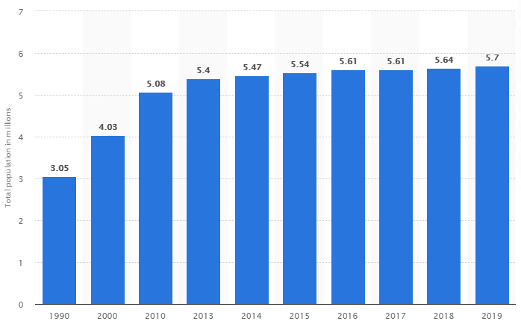
Fig 1.1 Total Population of Singapore between 1990 and 2019
Source: World Bank official website

This figure was made based on the information and data gathered from the official Singaporean government website.
Clearly, the chart is indicating a steady growth in the overall number of populations from 1990 until the recent data in 2019 reaching 5,7 million.
However, it is quite important to note that the total population includes citizens and permanent residents. Let us have a deep look at the percentage of citizens and permanent residents in order to know if the country encourages brining labor force from abroad. The Singaporean government statistics shows that There were 3.50 million Singapore citizens as of Jun 2019. Together with 0.53 million permanent residents (PRs), there were 4.03 million residents. Non-residents totaled 1.68million, and include dependents, international students, and individuals who are here to work. Overall, Singapore’s total population stood at 5.70 million.
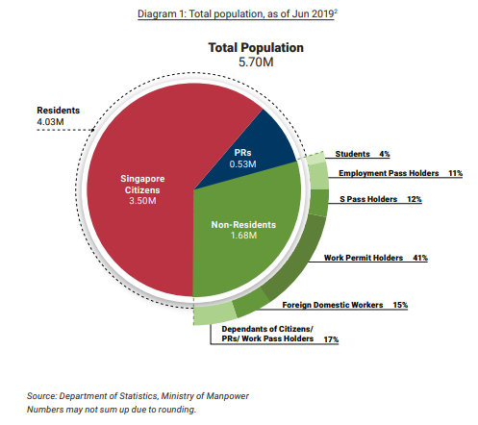
Fig 1.2. Division of the population in Singapore

The economic process is analyzed through three perspectives, the level, generation and distribution.
First the level of income, in this research paper the concentration will be mainly on use Gross Domestic Product rather than Gross National Income since the GNI measure that we use today is not available for the earlier years before 1962.

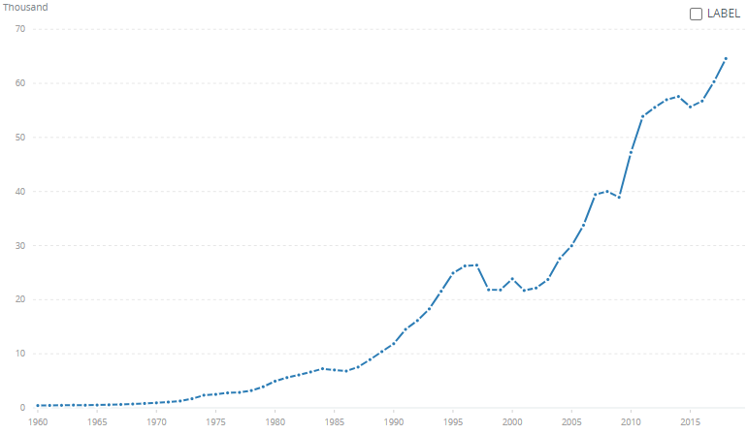
Fig 1.3 GDP Per capita in Singapore
Source: World bank official website

Here is some of the main points according to this figure from the world bank statistics:
- In 1965, Singapore's nominal GDP per capita was around US$500. It is the same level as Mexico and South Africa.
- In 1990, GDP per capita had risen to about US$13,000, surpassing South Korea, Israel, and Portugal.
- In 2015, GDP per capita was about US$56,000. almost caught up with Germany and the United States.
Second, the generation of income. Just as important as the level of income is: how we produced it, and what resources did they use?
- Output per hour worked has increased considerably.
In 2015, Singaporeans worked 2,300 hours.
This year Singaporeans are expected to work only 1,400 hours.
These days they are now generating nearly three times as much income as 50 years ago.
The carbon intensity of our economy has fallen sharply.
In 2015, they emitted 0.2 kilograms of carbon to produce a dollar of output.
Today, they emit just 0.05 kilograms.
Third, the distribution of income.
- Income distribution has become more equal, thanks to heavy investments in building human capital and skills as well as a tax and transfers system that has become more progressive over the years.
In 2015, the Gini coefficient after taking account of taxes and transfers was 0.41.
Today, it is 0.36.
- Wealth inequality has remained more stubborn though.
Today, the top 1% and 10% of wealth holders in Singapore own around 20% and 60% of total wealth respectively.
This is little changed from 30 years ago, when the data was firstly collected.
GDP Growth annual:

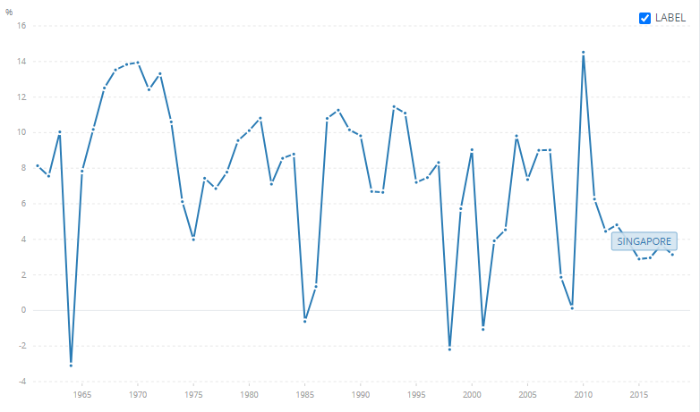
Fig 1.4 GDP growth in Singapore
Source: World Bank official website
Inflation rate:
The inflation rate is an economic parameter which very important while considering starting any project in any country. According to Investopedia, the Inflation is a quantitative measure of the rate at which the average price level of a basket of selected goods and services in an economy increases over some period of time. It is the rise in the general level of prices where a unit of currency effectively buys less than it did in prior periods. Often expressed as a percentage, inflation thus indicates a decrease in the purchasing power of a nation’s currency.
The figure below represents the inflation rate in Singapore in percentage from the period of time between 1984 until 2020.
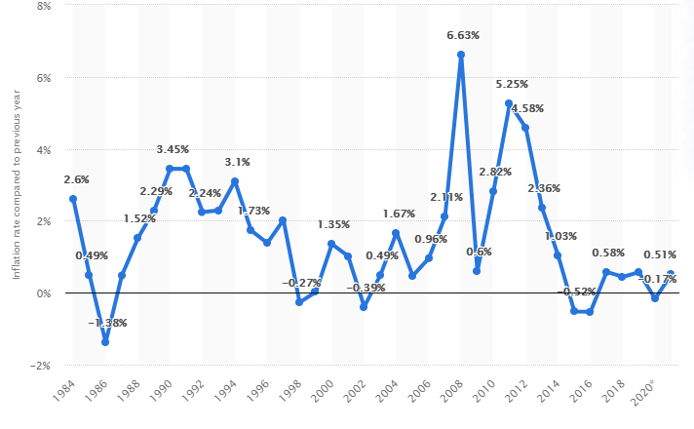
Fig 1.5 Inflation Rate in Singapore between 1984 until 2020
Source: world bank official website

As we can clearly observe from the figure is going up and down but it reached a reasonable percentage by 2020. In fact, looking back to the history, the highest inflation rate reached was exactly in 2008 during the global economic crisis, a crisis that influenced directly the Singaporean economy, the peak was at 6.63 %. Then it dropped by 2010 reaching 0.6 %. so, the country has managed to surpass the crisis rapidly and in a very short period of time. after that a decrease gradually reaching -0.52 percent by 2014. Moving to a stable percent almost between 2016 until 2018.
Going through different forecast concerning the inflation rate in 2021 will decrease even though the current crisis with Covid19 .

Unemployment rate:

Generally, investors are interested and digging deep into this indicator in order to see what sectors are eventually losing jobs faster. That is why, we considered while analyzing the general economic characteristics of the country.

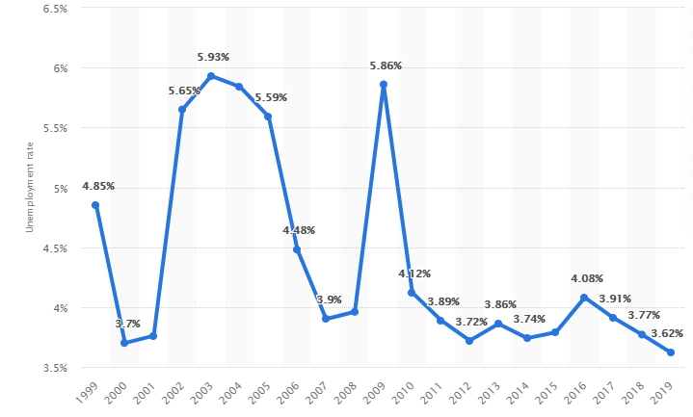
Fig 1.6: Unemployment rate between 1999 and 2019
Source: World Bank official website

The rate of unemployment rate as we can detect from the figure 1.5, we can see multiple changes the highest peak was in 2003 reaching 5.93% unemployment rate
A similar percentage was in 2008 during the global economic crisis and a graduate reaching 3.62 % in 2019 and a lot of forecasts from different resources has predicted it to keep falling.

1.2. The structure of the ‘’MONACO OF THE EAST’’ economy and its path towards the current situation

Singapore’s economy is one of the most open, and at the same time competitive, markets in the world. According to the 2011 World Bank Ease of Doing Business Index, Singapore is ranked first in the world for doing business – ahead from Hong Kong and New Zealand. Another amazing ranking that we should ignore is the third in the World Economic Forum’s Global Competitiveness Report to come behind Switzerland and Sweden.

The best description that we can give as an economist is a mixed economy.
Although the country promotes free-market policies and practices, this has come simultaneously with a noticeable government intervention too, to be specific in macroeconomic management and major factors of production such as land, labor and capital resources.
It is clear that both the free market and the state have a high degree of influence on the economy. This unique, yet highly successful, form of economics has been dubbed as the Singapore Model.

Both sectors of Services (72.8 percent) and Industry (27.2) made up the entirety of Singapore’s GDP in 2010. As for the Agriculture’s contribution on the other hand was virtually irrelevant – statistically it accounted for zero percent of the GDP. this shows the huge participation of these two sectors into the economy as a whole.
Singapore independence took place in 1965, since then, the Industry has been an essential element of the economy. Manufacturing in particular has been the cornerstone of Singapore’s economy. In spite of the fact that Singapore has concentrated on digital and electronics manufacturing for the past forty years, the country has diversified into other forms of manufacturing. The government initiatives and subsidies brought up biomedical and pharmaceutical manufacturing to become the burgeoning industries in Singapore at the moment.
Let us not forget the petroleum and petrochemicals industry. Singapore has the third largest oil refinery in the world, behind Rotterdam and Houston.
The Singapore Petroleum Company (SPC) is a leading player in the petroleum industry and is engaged in exploration, production, refining and distribution. Remarkably, despite not having a single drop of proven oil reserves in the country, Singapore is a net exporter of oil - exporting 1.374 million barrels of oil/day and importing 1.195 million barrels/day. This makes Singapore the 18th largest exporter of oil in the world.
Singapore is also a global leader in services, particularly in finance. Singapore’s banking system is considered to be among the strongest in the world. Singapore has the fourth largest foreign exchange market in the world after London, New York and Tokyo. The Singapore Government Securities is the only Asian market, besides Japan, to be part of the Citigroup World Bond Index. The Singapore Exchange (SGX) was also the first demutualized, integrated securities and derivatives exchange in Asia-Pacific. Singapore is recognized as one of the premier asset management centers in Asia with more than 200 international asset management firms. Finally, the Asian Dollar Market in Singapore has become an influential element to the economic development of the whole of Asia with assets of more than US$582 billion recorded in 2004.
Apart from finance, tourism is the other major service industry available in Singapore. In 2010, tourist arrivals to Singapore hit a record high of 11.638 million visitors with tourist receipts of more than S$18.8 billion. Thanks to government initiatives, tourism has diversified into niche markets such as medical tourism, the gaming industry and the MICE (Meetings, Incentives, Conferencing and Exhibitions) industry. With the advent of the two new integrated resorts in 2010, tourism expenditure in sightseeing and entertainment grew by an astonishing 1,834 percent in 2010.
As such, after two years of negative industrial production growth due to the global financial crisis, Singapore’s industrial production growth rate for 2010 was the third highest in the world at 25 percent – behind Qatar and Taiwan. The list of industries in Singapore include electronics, chemicals, financial services, oil drilling equipment, petroleum refining, rubber processing and rubber products, processed food and beverages, ship repair, offshore platform construction, life sciences, and entrepot trade.

1.3. Main difficulties that faces the Singaporean economy:

After investigating and reading multiplies articles concerning the potential difficulties of the Singaporean economy. Here are some of the ideas that popped out during our research.
The bright model of Singapore that each country is striking to reach the level Another side of the Singaporean model is the challenges faced. The first appealing issue is the population. When we say population, we are more concerned about the labor force.
Singapore faces slower growth as the population ages, the workforce stagnates, and productivity weakens. The fertility rate has been falling for many decades, from 5.76 in 1960 to 1.82 in 1980 to 1.60 in 2000
The second issue is the inequality, in fact in comparison with most developed countries, Singapore seems to be unequal. Using the Genii coefficient which is the conventional measure of inequality for societies.
A third challenge is competitiveness. It can be looked at in many ways. One approach is based on how Singapore ranks in surveys. Singapore registers impressive rankings on competitiveness surveys (Table 1). It ranks 3rd (2nd in the previous year) in the 2018 World Economic Forum (WEF) Global Competitiveness Index and 2nd (2nd) in the 2018 WEF Ease of Doing Business rankings. In the 2017 INSEAD Global Innovation Index, it ranked 7th (6th).
For twenty-five years, Singapore has had the fastest growing economy in the world. In so doing it has also prevented all of the major downside costs that often accompany high growth, such as rapid inflation and chaotic use of land. That achievement is substantial and deserves the recognition that it has received. However, success breeds complacency, and for the future of Singapore past successes may be more dangerous than past failures. Policy formulas that worked in the past risk becoming so sacrosanct as to constrain needed adjustments for the future. Preventing this from happening is the challenge now facing Singapore.
From the other side, a lot of fears appears when it comes to the thinking in the long term, these fears were even revealed by the Prime minister of Singapore in 2015, According to Mr. Lee, the challenge is to keep Singaporean brand. Not only that, but the fact that that there was an identification of five major challenges to Singapore. They are managing external dependence, building a more robust domestic economy, reducing the role of government, improving the macroeconomic management of the economy, and understanding (and accepting) the implications of slower growth.

SECTION 2.
FOREIGN ECONOMIC ACTIVITY OF SINGAPORE:
INTERNATIONAL GOODS AND CAPITAL MOVEMENT

2.1. Export-import activity of Singapore (dynamics and structure)
The structure of trading industry in Singapore
Foreign investors interested in setting up a business in one of the largest and most prolific economic sectors of Singapore are advised to try the trading industry. Singapore is an international trading hub, as well as one of the friendliest countries in the world in terms of trading regulations.
According to the official Singaporean statists department, here is an overall figure that illustrates perfectly the numbers of exports and imports of merchandise of the country for the past 5 years between 2015 and 2019
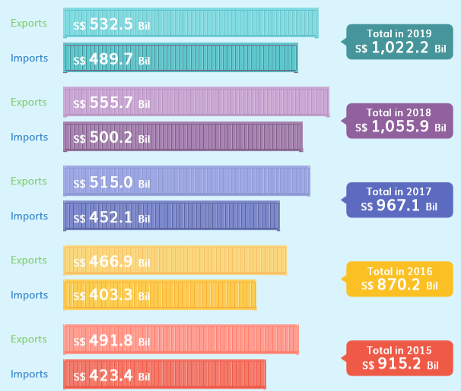
Fig 2.1. Total Merchandise Trade in Singapore between 2015-2019
Source: Department of statists of the Singaporean government
Between the Period of time from 2015 until 2020, the exports exceeded the imports, However the gap in between is not extremely large which a good economic sign to consider while evaluating any economy. However, in the last statics of 2019 we can observe that the total merchandise trade decrease 3.2 %.

Singapore is known for exporting various goods manufactured by local companies, and importing as well different goods among which the most appreciated and non-oil merchandise are:
- - machinery and equipment, such as electronics and industrial appliances;
- - household products which range from textiles to various house appliances;
- - agricultural products, beverages, and foodstuff, as well as raw materials;
- - transport equipment and machinery, but also auto vehicles spare parts.
Here are some Data provided by the Statistics department of the Singaporean government official website, the latest data is from 2019. That is why most of the data gathered will concern this year. That is due to limitations of other information. It was revealed the numbers of Machinery and transport equipment rank number one in both exports and imports, the second ranking goes for the chemicals and chemical products, the third ranking goes to Miscellaneous Manufactured Articles and respectively the food and live animals and oil (vegetable animals and waxes) third and fourth.

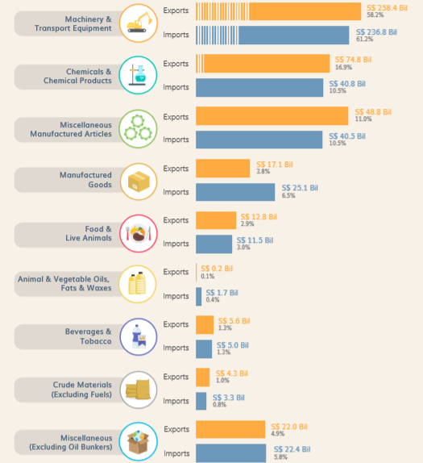
Fig 2.2 Non-oil Merchandise Trade by major commodity section,2019
Source: Department of statistics of the Singaporean Government

Singapore’s exports
As mentioned above, Singapore is one of the largest exporters in the world and its main trading partners are China, Malaysia, Indonesia, Hong Kong, and Australia. As a percentage, 14% of Singapore ’s exports go to China, Malaysia, and Indonesia import 12% each from companies in Singapore, as for Hong Kong and Australia, represent 7,5%, respectively 6% of the territory’s total exports. Other countries Singapore exports to are the United States, India, Japan and in Europe Singapore exports its products mostly in Germany, Belgium, the United Kingdom, and the Netherlands. When it comes to exported goods, on the top of Singapore’s list is refined petroleum that represents approximately 30% of all exported goods. Singapore also exports computers and computer spare parts, packaged medicines, and gold.

Imports in Singapore
It is a well-known fact that most Singapore imports are destined for re-export. On top of Singapore’s import list is petroleum that represents 35% of its total imports, followed by computer and computer spare parts that represent 10%. Singapore imports petroleum gas in smaller amounts. Singapore companies also import broadcasting equipment and office machinery. Most part of imported products by Singapore come from China and Malaysia and represent about 20% of the city’s total imports. Other trade partners are South Korea, Japan, and India in the Middle-East, but Singapore also imports from the United States, the UAE and Germany. In smaller percentages Singapore imports from other European countries such as Switzerland, France, and the United Kingdom.

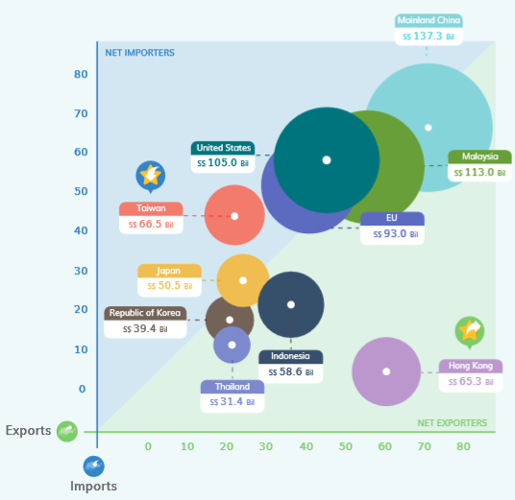
Fig 2.3 Exports and imports of the merchandise in Singapore
Source: The department of Statistics of the Singaporean Government

2.2. The scope and main directions of foreign direct investment in Singapore

According to World Investment Report 2019s , Singapore was the fourth largest recipient of FDI inflows in the world in 2018, after the United States, China and Hong Kong. FDI inflows rose to USD 77.65 billion in 2018, from USD 75.72 billion a year earlier and at their highest to date, according to revised figures of UNCTAD. Singapore is also a major investor abroad and has sought to diversify its investment beyond its traditional target markets in Asia, namely China, India and Vietnam in recent years. The main investors in Singapore are the United States, British Virgin Islands, Cayman Islands and the Netherlands. Financial and insurance activities are by far the main recipient of foreign investment, accounting for 54.5% of all FDI stock.

Singapore has based its economic development on a proactive strategy to attract FDI using its trade openness. Since the first publication of the World Bank's Doing Business ranking in 2003, the country has always been in the lead until 2018, when it was overtaken by New Zealand. The country maintained the second position in 2020. Being favorable for lending to foreign investors, a simple regulatory system, tax incentives, a high-quality industrial real estate park, political stability and the absence of corruption make Singapore an attractive destination for investment. The country has one of the best regulatory systems of the world for paying taxes (it is fast and cheap) and for enforcing contracts. In 2019, dealing with construction permits was facilitated (in terms of improvement of the risk-based approach to inspections, improvement of the public access to soil information and rationalization of the process of obtaining a building permit).

2.3. Assessment of Singapore investment climate and the degree of its
attractiveness to international investors

The investment climate in any country refers to the factors that can influence the investment procedure and the success or failure and it is mainly the concern of any investor while thinking of starting an investment in any country around the world. And since the project would be starting a pharmaceutical company in Singapore in this section the focus will be only on specific factors such as:
The Global Competitiveness Index 4.0 2019 Rankings
This index Covers 141 economies, the Global Competitiveness Index 4.0 measures national competitiveness—defined as the set of institutions, policies and factors that determine the level of productivity.
In the last report of economic forum, Singapore ranked number 1 in this list of 141 countries. this ranking shows the real scope of investment attractiveness of this country.

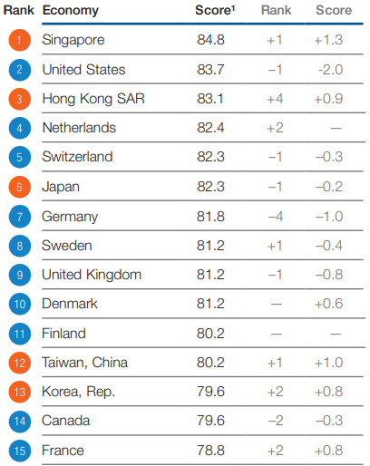
Fig 2.4 Global competitiveness Index list 2019
Source: World Economic forum repot 2019
1. Investment Capital
Private Investments: These refers to the investments made by financial organizations, companies and any other investors other than the government. In Singapore, it is possible to find investors, as long as companies put some effort in their search. There are private investors who are willing to invest in various industries, even where there are some risk factors present.
Government Funds: In terms of funds, the government of Singapore gives its support to emerging biomedical companies and startups. It is easier to set-up a company in Singapore due to strong government support. However, these grants are being provided only for 5 to 10 years, which is a short period of time for the kind of industry like Biomedical. This is due to the drug discovery and development, which takes at least 10-15 years to be established in the market. In addition, with the increasing number of companies, it's getting harder to provide grants.

Revenue: It is challenging for most of the companies in the Biomedical industry to generate money, especially since they invest a sufficient portion in R&D. Some of the products have been successful and they have entered well into the market. However, many companies decide to pull out of Singapore and move to countries like the U.S. where they have higher chances of receiving long-term support. Long-term support is essential since about 90% of all biomedical projects are subject to failure and only 10% have a breakthrough. Further, as mentioned earlier, Singapore’s government averts risks and requires security that they will benefit from their investments and because of this there is no longevity.
2. Land:
Strategic Location: There are many factors that companies take into consideration before setting up their headquarters in a foreign country. One of the main reasons why Singapore is a very convenient location for companies is because of its strategic location. It is in the heart of Asia-Pacific region, making it easier to reach and cooperate with other neighboring countries. Companies like Johnson & Johnson, Novartis, Roche, Takeda and many others have set up their corporate headquarters in Singapore.
Laws and Regulations: The other important aspect that attracts investors and companies, is the strong government regulations. This assures to the maximum level possible that all the practices would be done in ethical way. Companies will have certainty that their rights will be protected. Strong government regulatory framework also ensures transparency and honesty. It is essential for Biomedical companies, because they have to assure that their products' copyrights will be properly protected.
3. Labor:
Talent pool: Singapore has a very rich talent pool, and its labor force is amongst the most skilled ones. Having skilled labor is very important, especially in Biomedical industry. In addition, Singapore is very open to skilled foreign workers, which is another advantage for companies. However, the only thing that most workers in Singapore lack is creativity, which has to do more with their way of life.

Culture:
Culture refers to the way people work and their working environment which they interact with. Culture is inseparable when one talks about labor. We are built by our perceptions and values, and our daily practices are based on them. Based on studies, we know that the reason we do things differently has to do with our culture. In Singapore, people are very hardworking and intelligent, yet they strive to achieve what they are expected to achieve. They do what is asked to get done to their best ability, and they rely on their supervisors to guide them. In this kind of industry, it's essential to think differently and experiment. Especially, R&D requires an employee to experiment and make some decisions independently. However, in terms of their attitude and mindset, they are open-minded and welcoming to foreign nationalities.
4. Cost:
Set-up costs: It's easier to set-up a company in Singapore because of the incentives provided by the government. One of the factors that make the set-up cost considerably less expensive is the government support in terms of providing facilities, specifically in the Biopolis. Initially, this had attracted several foreign pharmaceutical companies to establish their headquarters in Singapore. Furthermore, in most of the countries, companies have a hard time getting patents and approval for setting up their subsidiaries.

SECTION 3
DEVELOPMENT OF AN INTERNATIONAL
INVESTMENT PROJECT TO ESTABLISH A PHARMACEUTICAL COMPANY

3.1. Analysis of the Biomedical industry in Singapore
Nowadays, the pharmaceutical industry is booming. The pharmaceutical innovation that we are living today is because of the driven technology and sciences. It is quite the right time to start a pharmaceutical distribution business. Pharmaceutical distribution companies can most easily be described as the middleman between the drug manufacturing company and the retail pharmacy or end user. This industry is recession proof, making it an incredibly advantageous venture for any savvy and potential entrepreneur.
Singapore is considered as Asia's fastest-growing bio cluster, and holds a prime role for expanding biomedical industry into Asian market. According to World Bank Ease of Doing Business Index in 2011, Singapore has been ranked as the best country in the world to do business in. In addition, Singapore holds the third place in World Economic Forum’s Global Competitiveness Report. The country's economy is ranked as a triple-A economy and its strategic location links around 4 billion Asian markets. All these along with strong government support make Singapore's environment one of the most competitive and business friendly. Looking at the past records, Singapore's market displays high potential and sustainable growth. According to the statistics from 2012, 50 manufacturing plants generated SGD$30 billion, SGD$1 billion had been invested in over 50 R&D Centers and 30 leading biomedical companies had established their branches across the county (“Biomedical Sciences”, n.d.). Singapore is also known as a strategic site for companies, especially pharmaceutical, due to strong government support, quality manufacturing track record, highly skilled manufacturing workforce, and partnership in process R&D. The following graph shows the annual compound growth rate of biomedical R&D expenditure by country. From this graph it is clearly evident that Singapore is trying to expand its market by investing in its research and development.
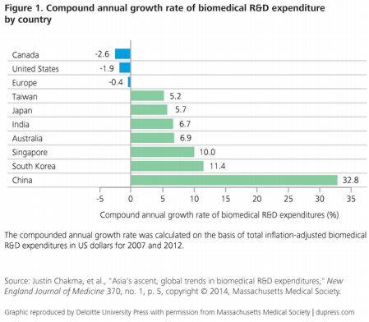
Fig 3.1: Compound Annual Growth Rate of Bio-Medical Industry (“Innovations from Everywhere”, 2014)

Porter’s Value Chain Model
The notion of a value chain was familiarized by Porter (1985), as ‘a systematic way of examining all the activities a firm performs and how they interact’. The biomedical industry value chain is extremely organized as the drug approval regulatory process governs it. This process includes drugs being ‘moved’ from discovery through development to marketing and sales (Rasmussen, 2014). An important factor that requires serious considerations in the development of value chain is the platform technologies. Platform technologies address the problems of technologies - one being the increasing range of drugs available and the other is refining the process of drug discovery. With increasing expenditures in R&D along with innovation posing a challenge to many pharma companies, alliances have become an attractive business model. Alliance’s purpose in the biomedical industry is providing means to assimilate activities of specialist companies as well to transfer across the different levels of the value chain. One of the alliance’s aspects is to perform this assimilation across geographic location. This is the main advantage of an alliance because it is an instrument that allows integration and formation of pharmaceutical cluster of regional and international alliances, paving way for cost management, access to new technologies and innovation. Alliances display the globalization of markets for biomedical industry. Over the decades, the biomedical industry has developed an outline of a value-chain through a series of practices, availability of technologies as well as markets and innovation.
The elements below were identified as components of value chain of Pharma Company (Rasmussen, 2004):
• Drug discovery
• Drug development
• Platform technology development
• Clinical trials
• Manufacturing Earlier,
the value chain of a pharmaceutical company was based on in-house development of drugs with R&D, drug design, registry, manufacturing and marketing and sales were all conducted without being outsourced. Resulting in the increase in cost, several countries, including Singapore, are now focusing on providing the means for outsourcing manufacturing of drugs; Amgen is the case for this. Specialization start-ups companies became the new business model along with a new value chain. Below is diagram representing a straightforward outline of both the pre and post value chains of pharma companies.

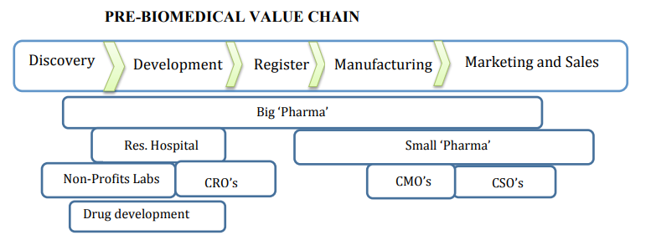
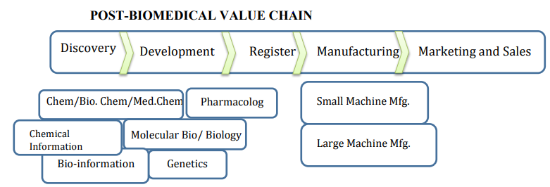
Figure 4.2. Pre and Post Value Chain of Pharmaceutical Industry adopted from (Granberg & Stankiewicz, n.d.)

However, with ever developing of platform technologies, two types of pharma value chain have developed in the biomedical industry. The first type of value chain is known as ‘Discover Molecules’. Pharma companies implementing this value chain will focus their technologies for delivering clinical candidates, rather than focusing on launching and marketing activities. This model strategy allows creative pharma companies to be found and be nurtured in this particular environment. The second type of value chain is ‘Implement Therapies’ wherein pharma companies embracing this model will practice market driven developments and launch products. They will focus on sourcing their pipeline externally along with managing regulatory complexity. Further, pharma companies will expand their access to markets and provide new value proposition to their market. This particular model allows growth in other industries such as e-health, outsourcing and will be able to forge new alliances. In its niche environment where resources are available and affordable, pharma companies will be able to perform end-to-end value chain (“Unleashing Pharma from the R&D Value Chain”, n.d.).

SWOT

SWOT Analysis is a business analytical tool undertaken by an organization to identify its internal strengths and weaknesses, as well as its external opportunities and threats. Below is a general SWOT analysis on the biomedical industry (“Investopedia”, n.d.):
It was a necessity to assess the industry in which this project is linked to and here are the results:
Table 4.1
Swot Analysis of the Biomedical industry
Strengths | Weaknesses
1. Market size  2. Regulatory standards  3. Academic institutions  4. Abundance of Capital  5. Cost Effective  6. Strong manufacturing base  7. Ability of high-quality skilled workforce  8. Excellent marketing and distribution network  9. Diverse Eco system  10. Well-developed networks and interindustry cooperation | 1. Human talent  2. Regulatory environment  3. Lack of coordination between industry and academic  4. Manufacturing of fake and quality medicines
Opportunities | Threats
1. Growing and Aging population  2. Emerging markets  3. Scientific Progress  4. Increase export potential  5. Marketing tie ups with multinational companies to sell their products in domestic market  6. Export of generic drugs to developed markets  7. Well educated labor | 1. Globalization  2. Reimbursement  3. Attracting Venture Capital  4. Drug price control puts undue pressure on price products, affecting the profitability of pharmaceutical companies  5. Public skepticism towards the use of the biomedical facilities  6. Cost containment measures may affect sales growth.  7. Heightened regulatory and safety hurdles.

Strength: The biomedical industry offers a great hope in finding cures for diseases. New biomedical products and services based on new research and development provide economic growth opportunities that do not depend on exploiting natural resources. In a field such as biomedical, knowledge is the key to success. Hence, active research communities combined with a highly skilled and educated workforce are the prime factors in the industry.
Weakness The length of time and the amount of money that it takes to develop a new biomedical drug, device or treatment is simply staggering and therefore they are the greatest limiting factors for the growth of the industry. Heavy investment and long development timelines mean that the industry remains dependent on risk capital. As a whole, the industry has yet to earn enough revenues to break even with the investment that has been made in its development.
Opportunities At present growth rates, Asia will have more than two billion people in middle class households within the next decade. Thus, with an increase in the growing and aging population, the biomedical industry is likely to experience a boom in the near future.
Threats Government authorities around the world are now concerned about the product safety and have paid special attention to the risk/benefit profile of pharmaceutical products. Both, Governments and private payers may regulate prices, reimbursement levels and/or access to the products to control costs or to affect levels of use of the products.
4.2 Features of the choice of ownership
When starting a business, one of the decisions that we need to take as a business leader one of the most important is the type of legal structure you select for the future company. This decision will have an influence on how much you pay in taxes, it will affect the amount of paperwork your business is required to do, the personal liability you face and how much money you raise.
It's important for business owners to seek help and advice from business professionals when considering the advantages and disadvantages of various business entities. They are the ones who can help when determining the needs of the owner.
To make such a decision there are some factors we need to consider such as legal liability, Taxation, cost, and especially Future needs.
The way we can imagine structuring this company is only as a partnership
And to be more precise a general partnership is the best option in this case. General partnership means that the partner manager is the one who is responsible for managing the company and assuming the responsibility for the partnership's debts and other obligations and duties.
The taxation system and procedure are one of the major advantages that the partnership offers. In fact, partnership doesn't pay tax on its income but "passes through" any profits or losses to the individual partners, which in this case is the most suitable for my idea.
As for the organizational structure of the company, it is the next step in order to be most effective in achieving the purpose for which the organization is at the first place established.

Below we tried to provide a common functional structure of a pharmaceutical.

CEO (pharmaceutical distribution Research and development company)

Research and development manger
HR manager
Operations manager
Sales and Marketing Manager
Finance manager
Purchasing manager
Marketing Manager

Production Manager

Human resource Manager

Fig 4.3 Organizational Structure of the company

It is expected that Changes in business processes and organization may occur from time to time and this change is only done to meet customer needs that change frequently too. When focusing on the customer and the intended interactions with them, companies will have to adjust their existing processes and internal
structures. This is only a preliminary version of our pharmaceutical company.
4.3. Profit estimation and a deep assessment of the economic attractiveness of the investment project:
This is only an initial investment capital calculation ,it was made base on real numbers and after research :

It was mentioned previously at the beginning, that this project will be through an investor from Dubai. So, the first of all, the first step would be an initial calculation of the requirement initial investment capital to establish this company in Singapore.
The prices mentioned in the Table 3.1 below were taken from official resources and from the wholesalers, so they are the best in terms of quality price.
The table below illustrates the calculation of the investment requirement:
Table 4.2
Investment requirement for the pharmaceutical company
Name | Quantity | Price Per Unit per $ | Total $
Rent 1 Month | 1 | 15000 | 15000
Office deposit | 1 | 10000 | 10000
Components for the production for 1 month | 1 | 38000 | 38000
Furniture | 5 | 1500 | 7500
Research Equipment | 10 | 25000 | 250000
Production Equipment | 5 | 70000 | 350000
IT equipment | 15 | 1000 | 15000
Security Equipment | 15 | 300 | 4500
Registration License | 1 | 350 | 350
AECD Registration | 1 | 15 | 15
Transport equipment | 5 | 60000 | 300000
Stationary | 2 | 75 | 150
Kitchen appliances | 1 | 2985 | 2985
HR expenses of 1 month | 1 | 3500 | 3500
Cleaning of 1 month | 1 | 3000 | 3000
Total | - | - | 1000000

Now the next step is to calculate the expenditures:
1-Salary calculations
Table 4.3
Salary calculations
 | Job position | Number of people | Wage/Month | Total Per Month
1 | CEO | 1 | 4500 | 4500
2 | Manager | 5 | 3500 | 17500
3 | Executive assistant | 1 | 1600 | 1600
4 | IT specialist | 1 | 3000 | 3000
5 | Biomedical engineer | 5 | 2650 | 13250
6 | Cleaner | 3 | 1000 | 3000
 | Total | 16 |  | 42850

The salary expectations were taken from thepayscale.com and indeed.com .
Total expenditure

Table 4.4
Total expenditure
Type of expenditure | Cost | Data
Rent (industrial space and offices) | 15000 | Monthly
Salaries | 42850 | Monthly
Chemicals and components | 30000 | Monthly
Electricity | 1500 | Monthly
Water | 1000 | Monthly
Internet | 500 | Monthly
Insurance | 500 | Monthly
Gasoline | 2000 | Monthly
Total | 93350 | Monthly
93350*12 | 1120200 | yearly

Expenditure
Taking into consideration the growth of inflation,
Inflation in 2020 in Singapore is -0.17 %
Predicted Inflation in 2021 is 0,51%
Predicted Inflation in 2022 is 1.9%
Table 4.5
Total expenditure
Expenditures (USD) | Year
 | 1 | 2 | 3
Rent (industrial space &offices) | 150000 | 150765 | 153629,535
Salaries | 557050 | 559890,955 | 570528,883
Chemicals and components | 360000 | 361836 | 368710,884
Electricity | 18000 | 18091,8 | 18435,54
Water | 12000 | 12061,2 | 12290,362
Internet | 5000 | 5025,5 | 5120,984
Insurance | 5000 | 5025,5 | 5120,984
Gasoline | 24000 | 24122,4 | 24580,725
Total | 1156050 | 1161945,855 | 1184022,826
Estimated Revenue
Table 4.6
Estimated revenue
N’’ | Services | Expected number of productions | Price $ | Total Per Month | Total  Per year
1 | drug for Covid 19 for Government | 4000 | 20 | 80000 | 960000
2 | Antidepressions drugs Private pharmacies | 2500 | 10 | 25000 | 300000
3 | Paracetamol drugs | 2500 | 5 | 12500 | 150000
4 | Antibiotics | 4000 | 10 | 40000 | 480000
 | Total | - | - | - | 1890000

Estimated revenue
Table 4.7
Forecast Revenue
Estimated revenue | 1 | 2 | 3
Total | 1890000 | 1899639 | 1935732,141

Calculating indicators of investment effectiveness
Table 4.8
Net profit calculation
Indicators | Year
 | 0 | 1 | 2 | 3
Investment in USD | 1000000 | - | - | -
Revenue of the sales USD | - | 1890000 | 1899639 | 1935732,141
Expenditures USD | - | 1156050 | 1161945,855 | 1184022,826
Profit before taxation, SD | - | 733950 | 737693,145 | 751709,315
Tax 17 %, USD | - | 124771,5 | 125407,834 | 127790,58
Net Profit USD | - | 609178,5 | 612285,311 | 623918,735
Inflation rate in Singapore in 2020 = -0.17%
Predicted inflation rate in 2021 = 0.51%, and in 2022 = 1,9%.
Interest rate= 5,75% the best choice of the alternative in the banks.
Risk = 10%
- i2020 = (1-0.0017) * (1+0.0575) * (1+0.1) = 0,9983*1.0575*1.1 –1 = 0.1612
- i2021 = (1 + 0.0051) * (1+0.0575) * (1+0.1) = 1.0051*1.0575*1.1– 1 = 0.169
- i2022 = (1 + 0.019) * (1+0.0575) * (1+0.1) = 1.019*1.0575*1.1– 1 = 0,185

1 year - 1/ (1+0.1612) = 0.87
2 year - 1/ ((1+0.1612) *(1+0.169)) = 0.74
3 year - 1/ ((1+0.1612) *(1+0.169) *(1+0.185)) = 0.63
Table 4.9
Investment effectiveness indicators
Year | Investment | Net Profit | Cash flow | Discount rate | Investment | Cash Flows
0 | 1000000 | - | - | - | 1000000 | -
1 | - | 609178,5 | 609178,5 | 0.87 | - | 529985,295
2 | - | 612285,311 | 612285,311 | 0.74 | - | 453091,13
3 | - | 623918,735 | 623918,735 | 0.63 | - | 393068,8
Total | 1000000 | 1845382,546 | 1845382,546 | - | 1000000 | 1376145,09
- Calculating Net present Value
Determine the discount rate:
і = (1+0,0625) х (1+(-0,017)) – 1 = (1.0625$×0.983)$ -1=0.044
Calculation of NPV
NPV=$(\frac{609178,5}{1.044}$)+( $\frac{612285,311}{〖1,044〗^2}$)+( $\frac{623918,735}{{1.044}^{3}}$)-1000000
= (583504,310+561762,62+548741,19)-100000
=693908,1>0
The international project should be adopted because the cost(value) of the company will increase, the stock price will increase.
- Payback Period

Calculating the payback period would be the next for me to assess and evaluate efficiently the attractiveness of the international investment project.
In fact, the Payback Period is a tool for each investor to know how many times it takes to get their initial investment.
the Pharmaceutical Company will initially invest $1 million that is expected to procure for the company $400,000 each year in average. The payback period for this investment is 2.5 years we got this result splitting $1 million by $400,000.
- Index of profitability

The third step would be calculating the index of profitability. This index is calculated in order to project the value created per only one unit of investment. in this case here is all the figures illustrating the calculation.

Net Present Value (NPV): $693908,09
Expected Cash Flows: $1376145,09
Profitability Index (PI) = 1376145,09/ 1000000 = 1.1376
PI > 1 ⇒ Accept the project

CONCLUSION

In the process of the research paper, we came to the point that potential investors and companies look into different factors thoroughly while considering entering a new market. In the case of Singapore, the major factors that attract companies and investors are strong regulatory framework, tax incentives and talent pool. Strong government policies and support are in favor of attracting investors into Singapore's biomedical industry. In addition, government grants for start-ups and researches give them a starting point. Singaporean government should have patience when it comes to return on investment in the biomedical industry. In the biomedical field, it takes a decade or more for the drug discovery and development itself. Even after the drug discovery period, there is a long process of clinical trials and production for the drug to reach the commercialization stage and market. Despite Singapore's initial idea being to become a biomedical hub, its focus has shifted with the change in the overall management. These changes are for a reason, and it might be the right thing to do. Singapore has a good potential in medical technology and it has one of the best healthcare systems.
Although some challenges may be faced by the potential investors, yet it still remains attractive for investors. Lastly, Singapore has to look into other industries and sectors that have high potential and use a strategy that will bring prosperity for both parties.
Through the First section, it was well defined that the Singaporean economy and all the major characteristics from GDP rate, GDP growth, unemployment, Inflation and demographics are one of the best in comparison with all the other countries around the world, so it is recommended to install an international investment in such an economy where all the characteristics are impressive and tempting as well.
As for the second part of our findings concerning the economic activity from exports and imports and foreign capital investment, all the analysis and index were in favor of the idea of establishment of this international investment project and we ended the last section with accurate and concrete evaluation of project. The calculation was based on real estimated prices and values. We tried to use concrete data in order to get the best results of estimation.
This research report could potentially give an in-depth insight on Singapore
Biomedical industry to the government, private researchers as well as local and
foreign investors. It could be greatly beneficial to the government as they can learn and understand the emerging concerns and challenges faced by the foreign investors.
This could in turn help them to develop and their strategies and policies that could be mutually beneficial to both stakeholders. Moreover, this report provides significant findings in terms of future actions that should be taken by the government which are in favor of their goals. Furthermore, this report can serve as a guide for private researchers as they can learn about private companies’ expectations from them. This report can provide useful insights to potential investors as well as the local investors in Singapore. Potential investors can learn about the present challenges faced by companies and can decide whether to proceed with their investment or not. The
following report will, also, point out some of the advantages of investing in
Singapore’s biomedical industry. Finally, this report will possibly provide insights on where the biomedical industry is headed in the near future and what are other options investors may want to look into.

All of these findings lead us to the conclusion that Singapore’s biomedical industry is expanding and we should always think about the long run, Companies have been coming to and going out of Singapore, yet it’s still remains attractive for investors.
Lastly, Singapore has to look into other industries and sectors that have high potential and use a strategy that will bring prosperity for both parties , a lot of other international investment projects can be a great success in this country .

References

World Economic Forum.The 2002–2003 Global Com-petitiveness Report

National Science and Technology Board (1996)Na-tional Science and Technology Plan. Singapore:NSTB

data.worldbank.org/country/SG

www.singstat.gov.sg/find-data/search-by-theme/population/population-and-population-structure/latest-data

Biomedical Sciences Industry In Singapore. (2014). Retrieved from
http://www.singhealthacademy.edu.sg/Documents/ProgrammesAndEvents/A
STAR 22Jan14-(1000 - 1030)- Role of EDB Singapore.pdf

Mathi, B., & Mohamed, S. (2011). Unmet social needs in Singapore: Singapore's social
structures and policies, and their impact on six vulnerable communities (p. 13).
Singapore: Lien Centre for Social Innovation, Singapore Management University.

Healthcare in Singapore. (n.d.). Retrieved from https://www.edb.gov.sg/content/edb/en/industries/industries/healthcare.html

Journal of Biomedical and Pharmaceutical Engineering. (n.d.). Retrieved from http://www3.ntu.edu.sg/bmerc/contents/JBPE/index.htm Lim, H., & Wei, L. (2010, January 1)

Singapore Compact. (n.d.). Retrieved February 10, 2015, from
http://www.csrsingapore.org/c/news/103-singapore-becoming-ngos-preferred-base
Singapore Economic Development Board. Industries - International Non-Profit Organizations.

(2014). Retrieved January 23, 2015, from
https://www.edb.gov.sg/content/edb/en/industries/industries/international-non-profitorganisation.html

Toh, M.H. and Choo, A. (2002) Economic contribu-tions of research and development in Singapore. InEconomic Survey of Singapore. Singapore: Ministryof Trade and Industry, pp 103–126

Koh, F. and Koh, W.T.H. (2002) Venture capital andeconomic growth: an industry overview and Singa-pore’s experience.Singapore Economic Review,47,2,243–267.

Kortum, S. and Lerner, J. (2000) Assessing the contri-bution of venture capital to innovation.Rand Journalof Economics,31, 674–692.

Kumar, S.S. (2000) Components of science-based inno-vation measurements and their links to public poli-cies.Technological Forecasting and Social Change,64, 261–269.

Headline: Singapore's 'key future challenges': Economy, population, identity

https://crea.smu.edu.sg/sites/crea.smu.edu.sg/files/news/pdf/TODAY_20150701_Headline%20-Singapore%27s%20%27key%20future%20challenges%27%20-%20Economy%2C%20population%2C%20identity.pdf

Singapore Economic Development Board. (n.d.). Singapore - A Base for International Nonprofit Organizations to Serve Asia’s Needs. Retrieved February 12, 2015, from
https://www.edb.gov.sg/content/dam/edb/en/industries/International Non Profit
Organization/downloads/IOProgrammeOffice.pdf

Amgen - About Amgen - Overview. (n.d.). Retrieved from
http://www.amgen.com/about/overview.html

A Case Study of the Pharmaceutical Industry in Singapore. Retrieved January 20, 2015, from http://www.iisd.org/tkn/pdf/sd_impacts_singapore.pdf

Shanmugaratnam, T (2015): “Singapore’s social policies: past, present, future”, speech
delivered at the SG50 Distinguished Lecture of the Economic Society of Singapore, 14
August.

World Bank (2016): Poverty and shared prosperity 2016: taking on inequality.

California's Biomedical Industry is Poised - BayBio. (2011). Retrieved from
http://baybio.org/californias-biomedical-industry-is-poised/

Erbes, A. (n.d.). Biomedical Business: Current Trends, Product Challenges and Future
Outlook. Retrieved https://www.sla.org/wpcontent/uploads/2013/05/HotTopicsinBiobusiness_Erbes.pdf

Nanyang Technological University. (n.d.). Retrieved from
http://www.ntu.edu.sg/AboutNTU/Pages/AcademicHighlights.aspx
Owczarzak, R. (n.d.). Eurofound. Retrieved from
http://eurofound.europa.eu/observatories/emcc/articles/emcc-dossier-on-theeuropean-biomedical-healthcare-sector

Overview of Singapore’s Pharmaceutical and Biotechnology Industry. (2013, January
1). Retrieved January 22, 2015, from
http://www.pharmacy.nus.edu.sg/programmes/BScPharm/Singapores Pharma
& Biotech Industry 2012-13.pdf

IMF (2017a): “Capital flows to Singapore: macroeconomic implications and policy
responses”, IMF Country Report, no 17/241.

Hall, R., & Jones, C. I. (1997). Why do some countries produce so much more per
worker than others? Quarterly Journal of Economics, 114, 83-1 16.

Huff, W. G. (1997). The economic growth of Singapore: Trade and development in
the twentieth century. Cambridge: Cambridge University Press.

Krause, L. B., Tee, K. A., Yuan, L. (tsao), KRAUSE, L., KOH, A. I. T. E. E. and LEE, T. S. A. O. Y. U. A. N. (1990) “Challenges Facing Singapore,” in The Singapore Economy Reconsidered. ISEAS–Yusof Ishak Institute, pp. 219–232.

School of Chemical and Biomedical Engineering. (n.d.). Retrieved from
http://www.scbe.ntu.edu.sg/Documents/SCBE Brochure260214single
(final).pdf

Toh, M. H., & Ng, W. C. (2002). Efficiency of investments in Asian economies: Has
Singapore over-invested? Journal of Asian Economics 13, 52-71.

Tsao, Y. (1982). Growth and productivity in Singapore: A supply side analysis. PhD
Thesis, Harvard University.
2
Tsao, Y. (1985). Growth without productivity. Journal of Development Economics
18, 25-38.
Yeoh, B. S. A. (2007). Singapore: Hungry for foreign workers at all skill levels.
Migration Policy Institute. Retrieve from
http://www.migrationinformation.org/Profiles/display.cfm?ID=570, February 1, 2011.
Young, A. (1995). The tyranny of numbers: Confronting the statistical realities of the
East Asian growth experience. Quarterly Journal of Economics 110, 641-680.

Unleashing Pharma from the R&D Value Chain - Featured Article - A.T. Kearney -
A.T. Kearney. (n.d.). Retrieved from
http://www.atkearney.com/innovation/featured-article/-
/asset_publisher/BqWAk3NLsZIU/content/unleashing-pharma-from-the-r-dvalue-chain/10192

Dasgupta, P. and David, P. (1994) Towards a neweconomics of science.Research Policy,23, 487–521.David, P., Hall, B.H. and Toole, A.A. (2000) Is publicR&D a complement or substitute for private R&D?A review of the econometric evidence.ResearchPolicy,29, 497–529.

David, P., Mowery, D. and Steinmuller, W. (1988)Theeconomic analysis of payoffs from basic research – anexamination of the case of particle physics research,CEPR Publication No. 122, Centre for EconomicPolicy Research, Stanford University, California.Dosi, G. (1984)Technical Change and Industrial Trans-formation. New York, NY: MacMillian

Ministry of Trade and Industry (1986)The SingaporeEconomy: New Direction. Singapore: SNP Publish-ers.Ministry of Trade and Industry (1991)The StrategicEconomic Plan: Towards a Developed Nation, Singa-pore, SNP Publishers.Mowery, D.C. and Shane, S. (2002) Introduction tothe special issue on university entrepreneurshipand technology transfer.Management Science,48,1, v–ix

